CSY2061- Mobile Application 1

Assessment 2

TimeLine Application (Android Studio)

Written Report

Author: Emily Elizabeth Fletcher

Student Number: 18410839

Date: 19/05/2022

Logins and Passwords

Standard User Logins:

Username: [UserAccount1@example.com](mailto:UserAccount1@example.com)

Password: Password

Username: [UserAccount2@example.com](mailto:UserAccount2@example.com)

Password: Password

Admin User Logins:

Account 1:

Username: Admin

Password: Admin

Features Implemented:

|  |  |  |
| --- | --- | --- |
| Feature Implemented | Degree of Implication | Comments |
| Splash Screen | Completed | Additionally added to make opening the app look more complete and less confusing to the end-user. |
| Register for the Application | Completed | User registers with First name, Surname, Email Address, Date of birth, Password, Date Created and Date last updated assigned automatically. |
| Users Login into the application | Completed | User Logins are provided in the first part of this document. |
| Update User Profile | Completed | The date is updated automatically when the button is pressed the activity is refreshed. |
| All registered users have access to the General Timeline | Completed | General Timeline is displayed on the user’s home page when they first log in to their account. Auto refreshes posts on a tick. The newest posts are shown at the top |
| All users can post a comment on the general timeline | Completed |  |
| Any comments on the timeline show the date of the post, the post content and the name of the user who posted. | Completed |  |
| Users can access MyTimeline activity, this shows all the posts for the user who is currently logged in. | Completed | Posts auto-refreshes on a device tick. The newest posts are shown at the top. |
| All posts in the myTimeline have the date. | Completed |  |
| A user can delete their posts in the myTimeline Activity | Completed | When the delete button is clicked the activity auto-refreshes so the data viewed by the user is up to date. |
| A user can update any of their posts in the myTimeline Activity | Completed |  |
| Administrators can log into the application | Completed | Admin Account is provided in the first section of this document. |
| Administrators can view all the registered user accounts. | Completed |  |
| Administrators can delete users | Completed |  |
| When an account is deleted, its posts are also deleted. | Completed | Automatically deletes users' posts when the account is removed |
| The administrator should be able to export users to a file | Completed | Toast message displays file location saved too. |
| Live Refreshes | Completed | When the user updates certain activities the activity closes and restarts, this allows the most up to date information to be displayed. |
| Empty Field Validation | Completed | The user cannot submit any activities that have empty fields in the form, which stops empty fields from being added to the database. |
| Timeline refreshes | Completed | The timeline refreshes automatically on device ticks. |

Code Explanation:

All the code written follows a similar pattern regarding the header comments. An example is shown below. These comments act as a header and as references.

The first comment block is the header. This contains the title, so you know the header matches the file. The purpose, tells you what the file's overall function is. The activity order, in this example A(admin) two, lets the reader have a better understanding of where this code file fits concerning navigation. In this case, the second activity is related to the admin part of the application. The code author, and the author's student number.

The second comment block is for citations for that activity. These are all the shorthand references for all code material that was used from other sources; the full references are included in this document at the bottom of this report.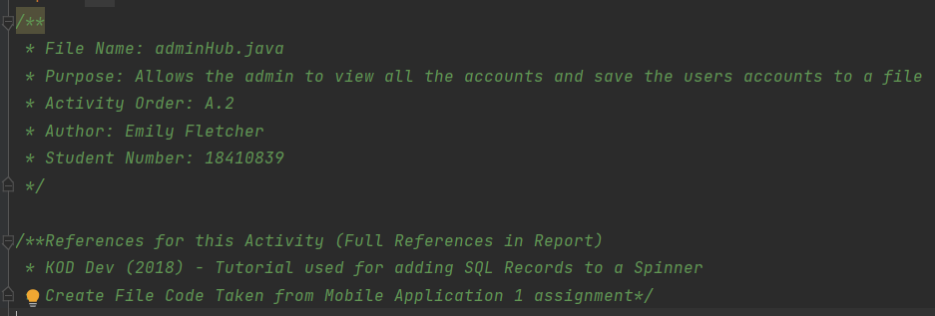

Object Classes

Three .java files are used to define objects. These objects are used to interact with the database. All the Object Classes contain a similar naming pattern where they are singular plural nouns. These files are admins, users, and posts. These files contain constructors for the objects as well as the getter and setters.

Admins

This file defines an admin object with the values of an ID, an email address and a password. It also has two constructors. The default Constructor sets all the values to whatever is passed to it by the main activities and the database connect files. The second constructor does not have an ID value set. This is because the admin object-related code does not need the ID value, however, the database does. The database uses the ID as the primary key, so it must be included, even if it is not used. Underneath this is the default setters and getters for the admin objects.

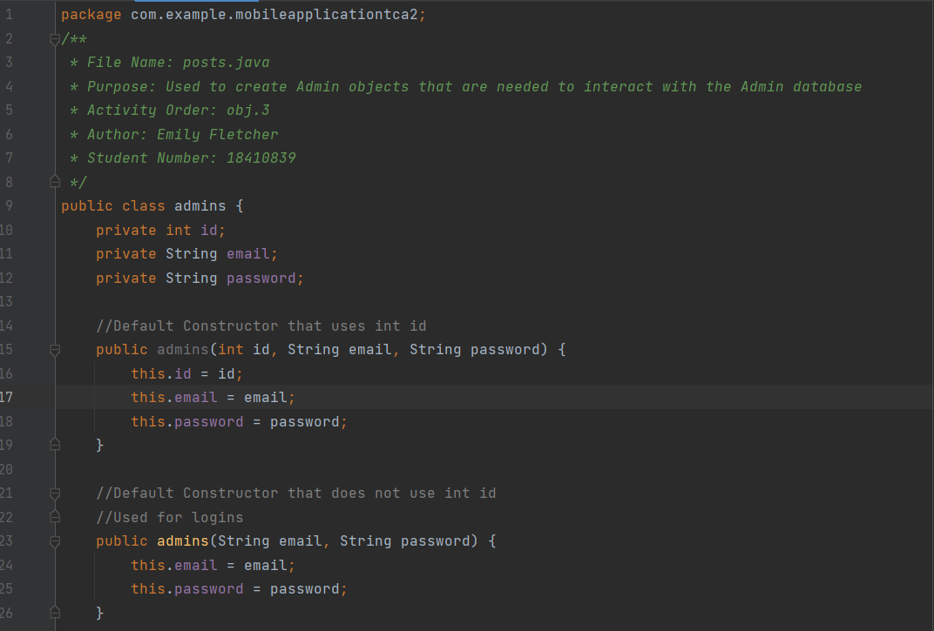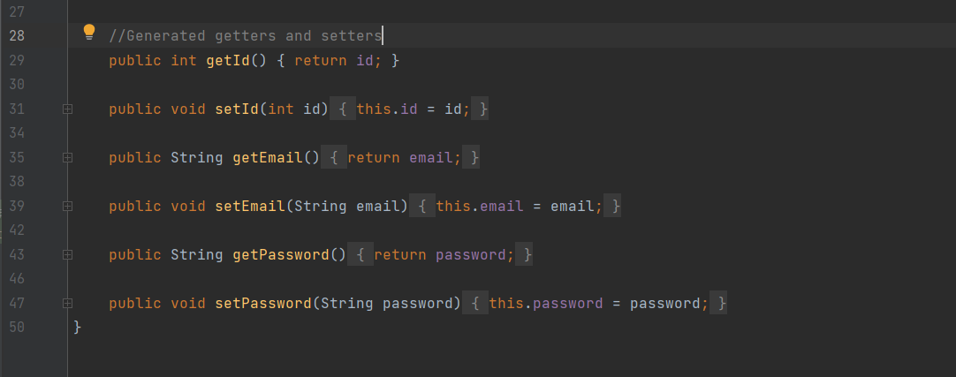

Users

This file is used to create users’ objects, user objects have the following values set to them, id, first name, surname, email, date of birth, password, date and created date. This file has three constructors within it. The first constructor is the default constructor, this is used to set all the values the object has. The second constructor is similar except it does not have the ID. This is because most of the activity code does not need the user ID to operate, however, the User ID needs to still be included to create the database to ensure that every record had a unique primary key. The third constructor contains the email and password values. This constructor is required for finding accounts for the user login. It only requires these two values as these are the only ones being retrieved from the database at that time. Underneath this is the default setters and getters for the user objects.

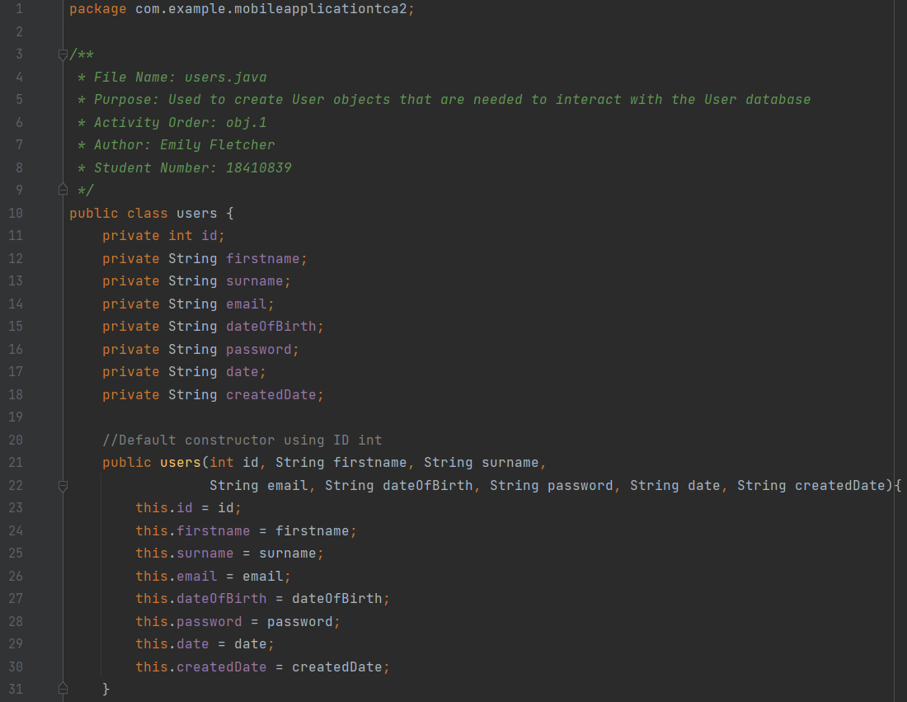

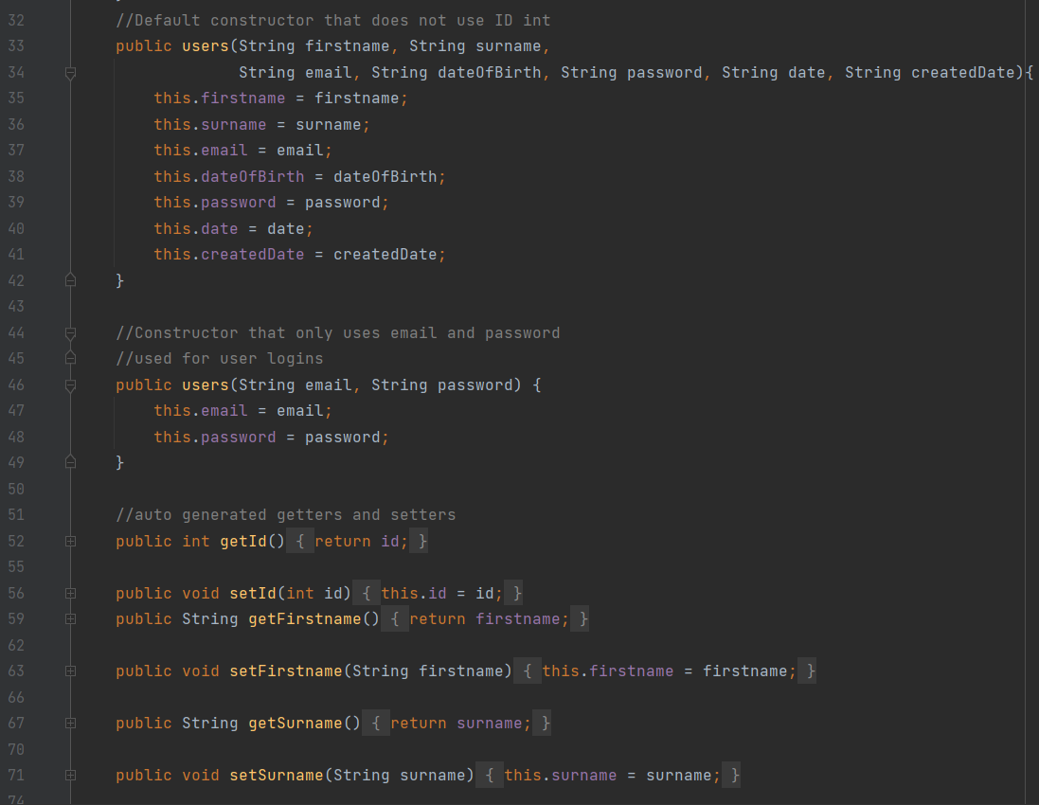

Posts

This file is used to create post objects, post objects have the following values set to them, post ID, user ID, post content, post time, first name and surname. This file contains three constructors. The first constructor is the default constructor, this is used to set all the values the object has. The second constructor is similar except it does not have the post ID. This is because most of the activity code does not need the post ID to operate, however, the post ID needs to still be included to create the database to ensure that every record had a unique primary key. The last constructor only creates the user ID and posts content. This constructor is used for editing a post. The reason these values are the only ones created is that the user ID is needed to ensure only the user's posts are found and the post content is the only part of the content that the user can update. Underneath this are the auto-generated getters and setters.

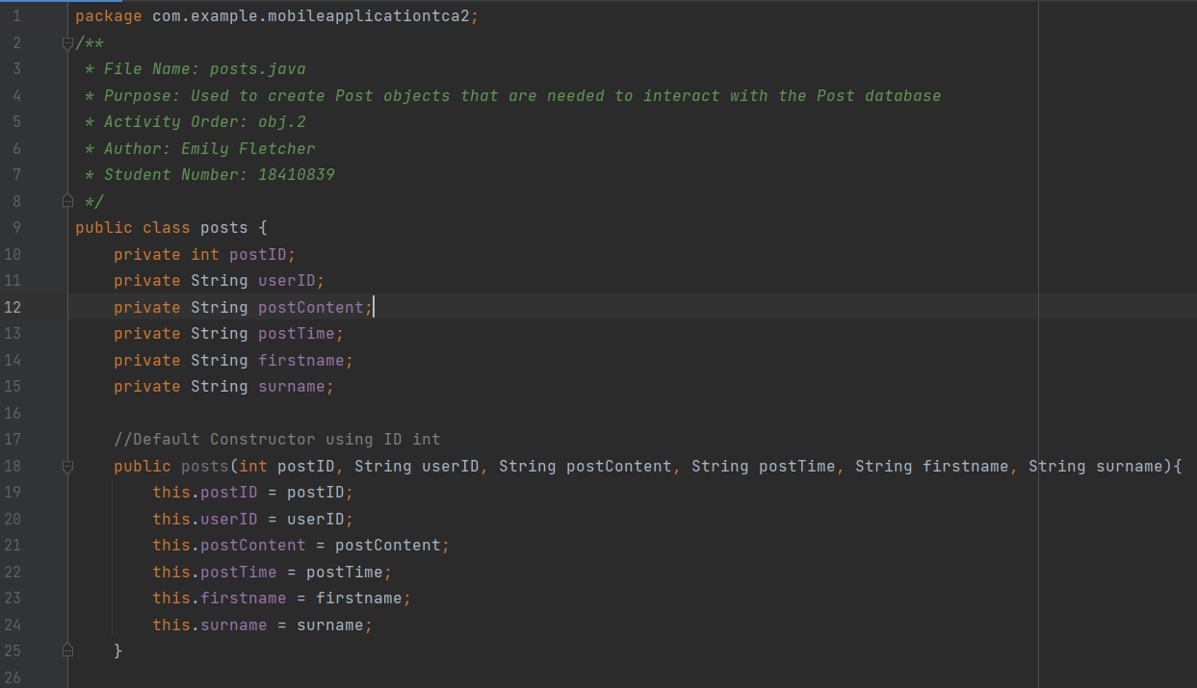

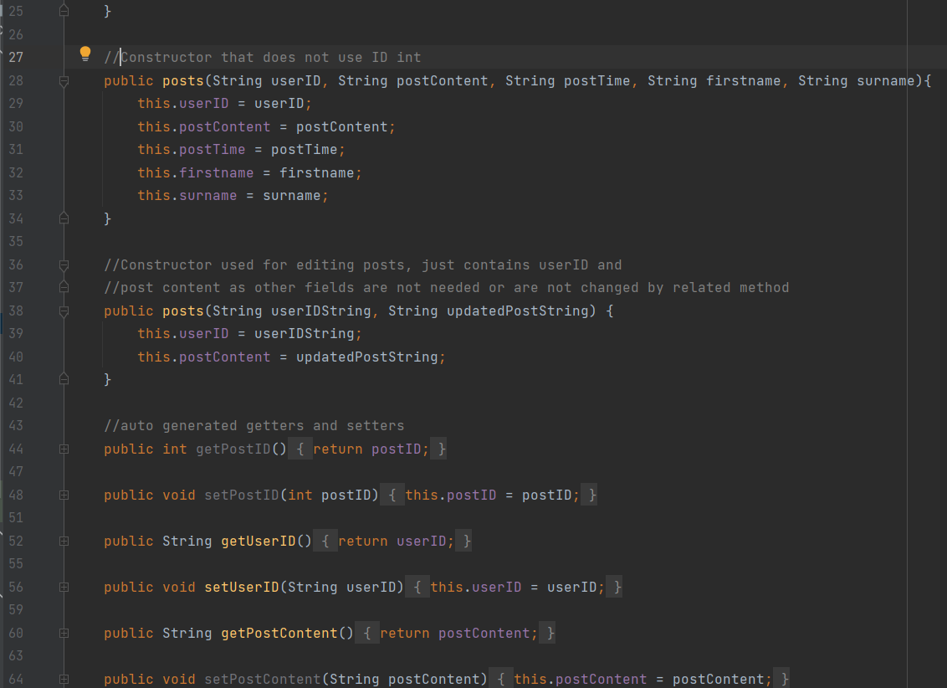

Database Classes

Three files are used for creating three database tables that the app runs off. These could all be moved into one file, however, they have been separated to make it easier for programmers to understand which method is related to which database. These three files all follow a naming pattern. They all have the prefix “dbConnect” this is because these classes allow the user to create data within the database and connect to it.

dbConnect

This class is used to create and communicate with the user's table. The first part of the class is defining the database. The name is defined of the total schema, the table name, and the version. Underneath that the values of the database columns are defined. These are defined so they take the values of a user object that is passed to them. The OnCreate method is used to initially create the user's table with all the columns needed. The onUpgrade method drops the table and recreates it so the data within it is up to date.

The addUser method takes a user object and takes the values from the object. It then uses the user's class to get the values and set them. Then all of those values are inserted into a writeable database with the defined table name.

The updateUser method takes a user object and a string id. This is similar to before in the way that it adds information to the database, however instead when it is inserted it overrides the row that has the user ID that was passed to the method. This is achieved by adding a where clause to the query.

The checkUsernamePassword method takes a user object. This method is used to compare input from the user to the database. A select query is used that selects any row where the user inputted email and password matches. If there is a record true is returned from the method, if there is no record then false is returned.

Below is a commented out method called verifyEmail, this was not implemented due to time constraints but if implemented it would use a similar method to the above to see if a record has the same email address as the one the user entered. If it does it would return true, otherwise, return false. If implemented in another activity this would allow a programmer to control whether duplicate emails are allowed in the application.

The method below this is fetchUser, this takes a string called accountID. This method is used to retrieve one single user, it is used as part of the myTimeline activity. This works by using the user's input as part of a where clause. If a userID matches then that record is returned to the activity that called the method.

There is a method below this that is very similar called fetchUsers, however, this method has a no where clause and does not take any data. This is used to return all the records in the user table. This is used in the adminHub activity where it is used to display a list of all users.

The last method in this class is the deleteUser method. This takes a String called userID. When called, this deletes a row where the userID matches a userID stored in the database. Then, if the int with the query inside returns anything above 0, the method returns true. This means that when there is a match there is a value stored, if there is no match then there is no value and nothing was deleted from the table.

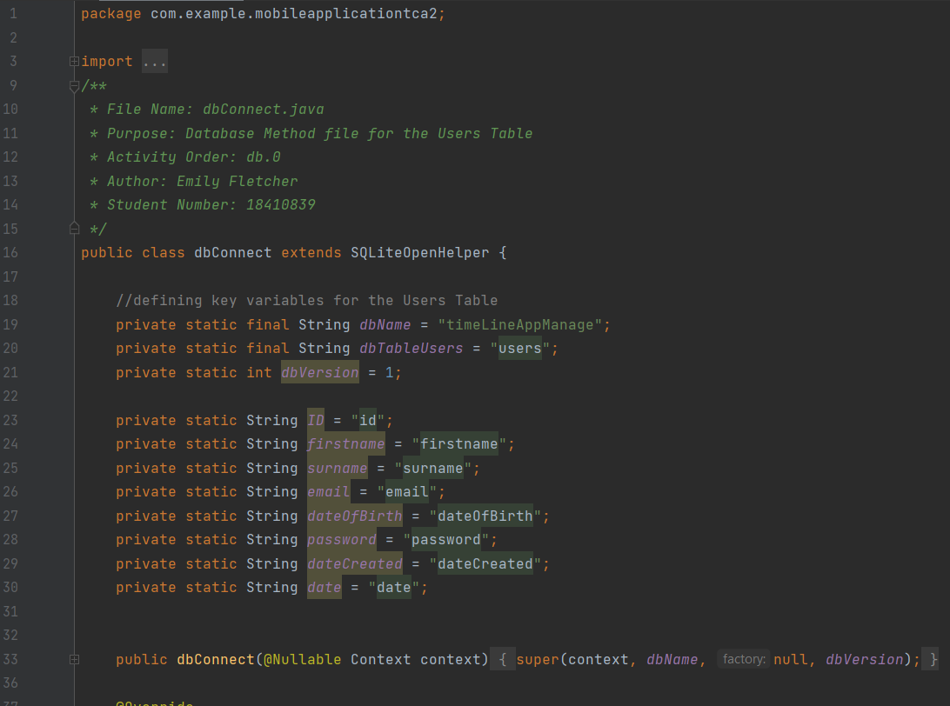

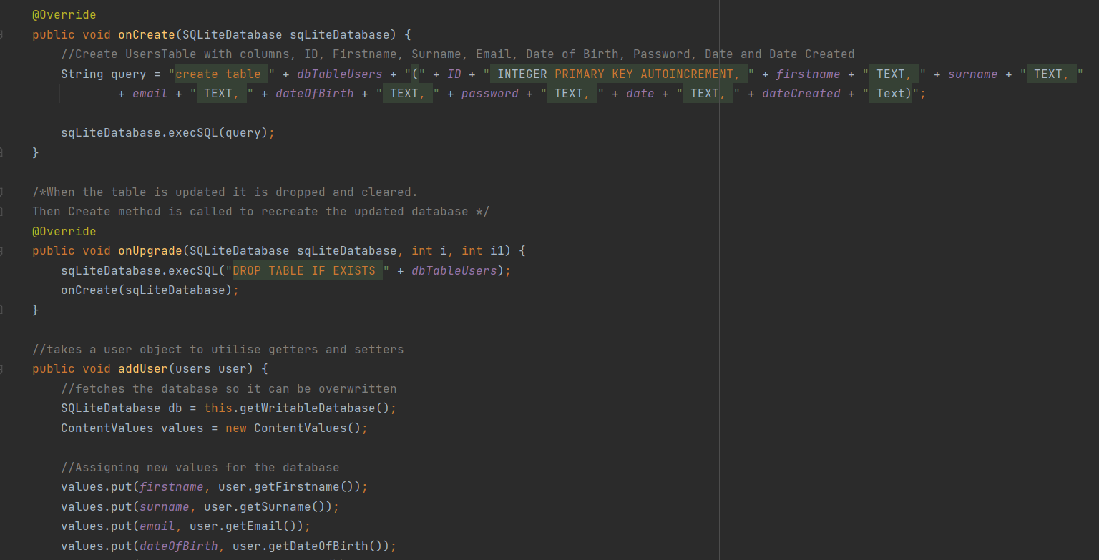

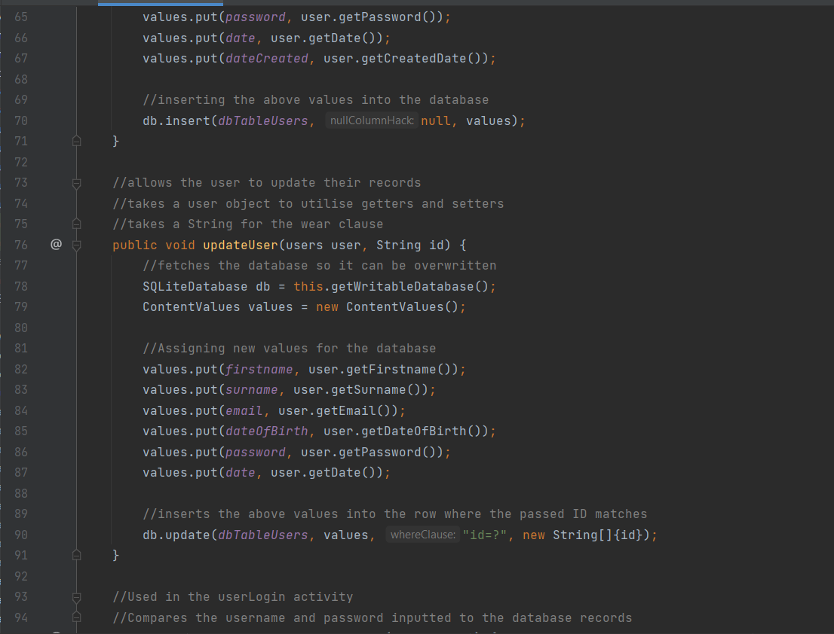

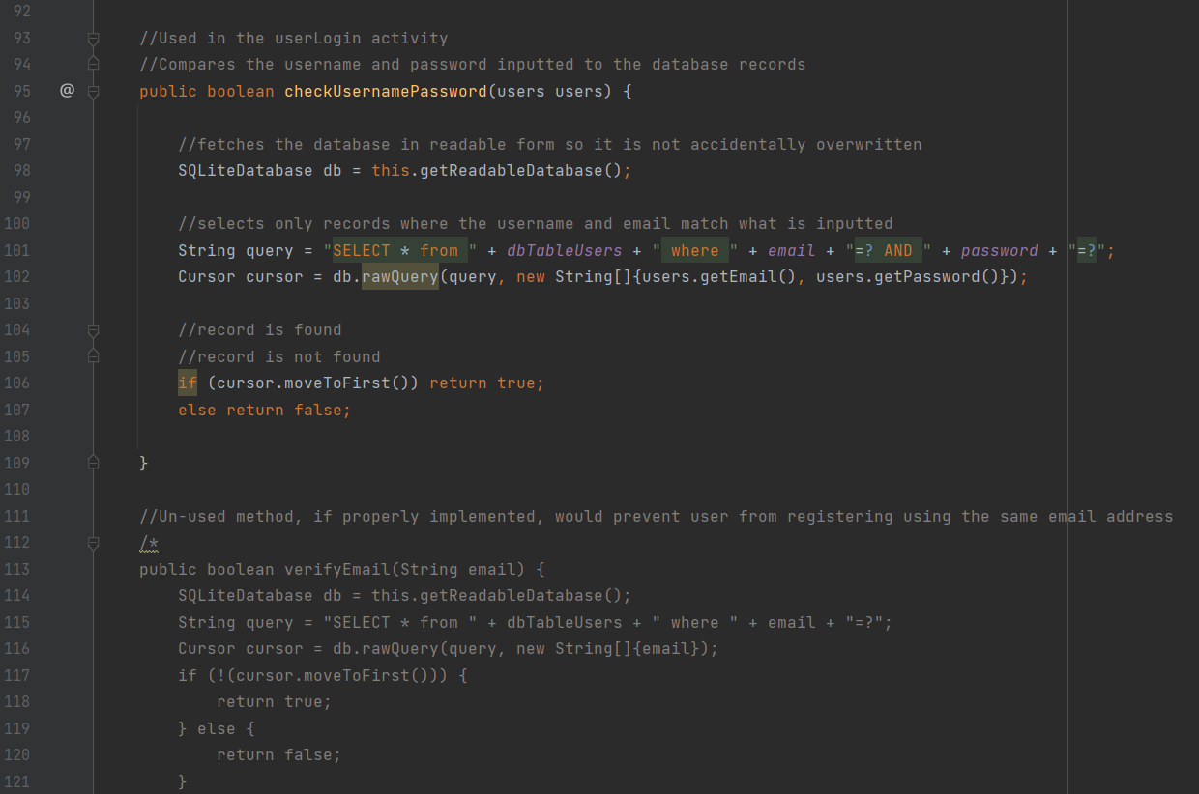

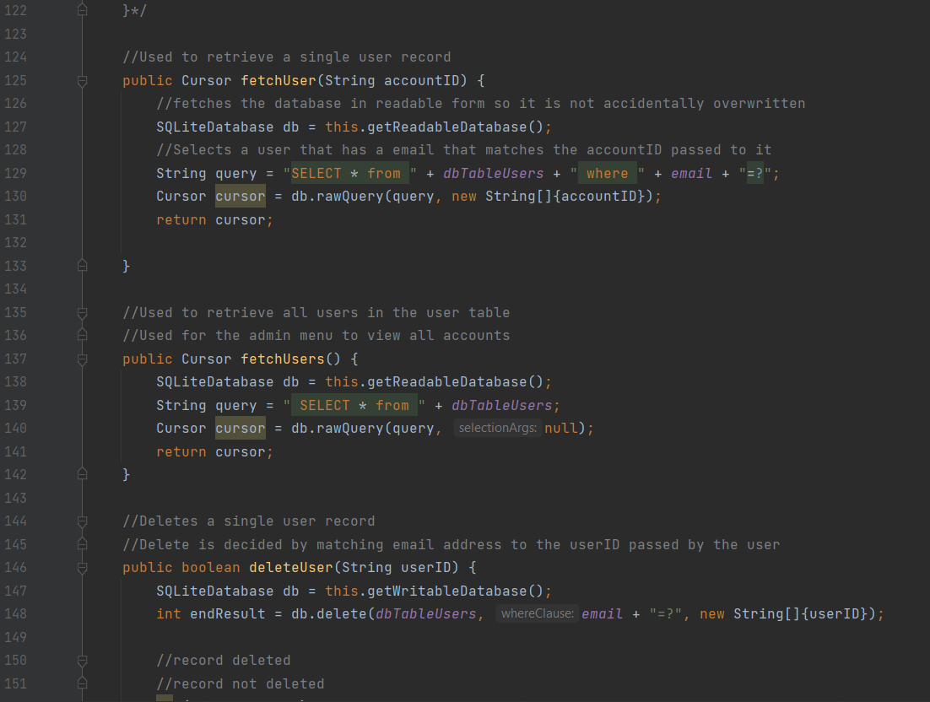

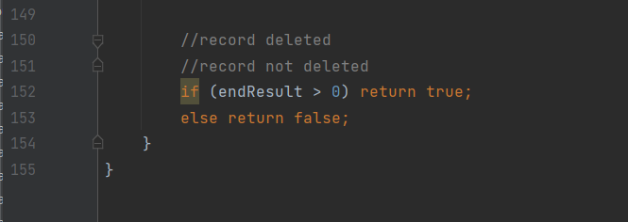

dbConnectAdmins

The first part of this class is the same as the one in above in the way it defines values for the database table and its columns. Its onCreate and onUpgrade have a very similar role and work almost the same way. The only difference is the onCreate uses the admin table rather than the user’s table, this table only contains the columns, ID, email and password.

The method underneath this is a repeat of a method seen in the dbConnection class. This is the checkUsernamePassword method. This takes an admin object that contains an email and a password and compares it to the records in the database. If a matching record is found it is returned as well as the method returning true.

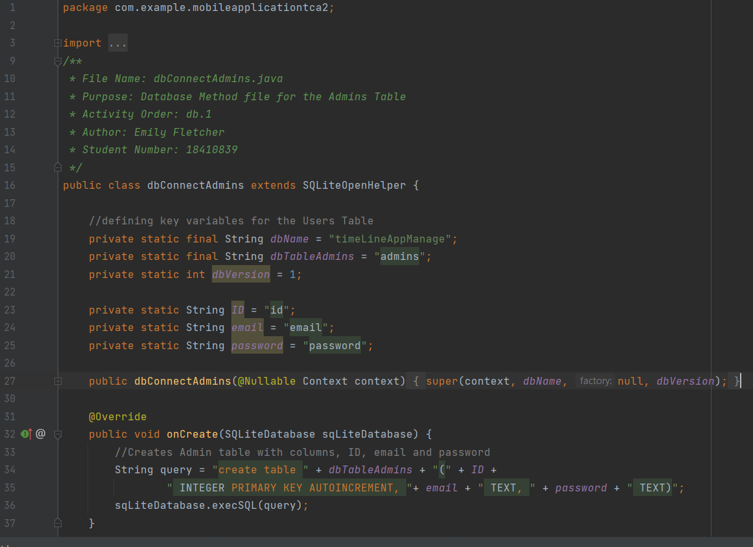

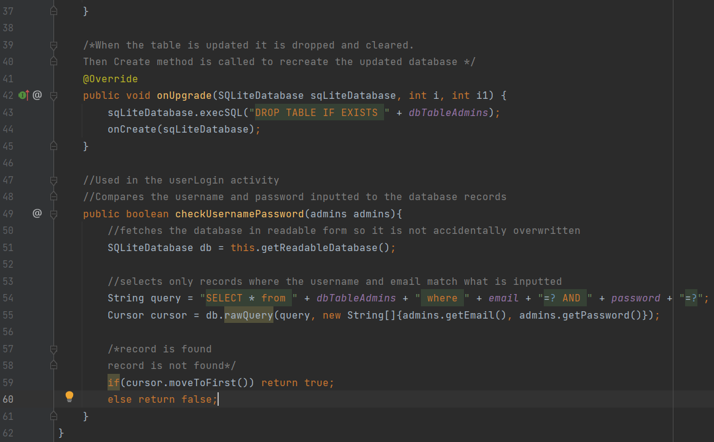

dbConnectPosts

a lot of the methods within the class are very similar to those that have been already explained. Therefore, the author will not cover them in too much detail. The first part of this class covers the database being defined, including the name of the database, its version and the values for the columns. There is an addPost method, this works the same as the addUsers method already explained. Below that is a viewPosts method, this method retrieves every post in the posts table, this is used on the main timeline that all users can see. There is another method below that called viewMyPosts, this is nearly the same as the method above it, except it takes a String value that is used as a where clause so only posts created by one user are retrieved. This is used in the myTimeline activity. Below are the methods for deleting posts, deleteAllUserPosts and deletePosts, these work the same as the deletes explained earlier in this report. Lastly is the editPost method, this works the same as the editUser method, also explained earlier.

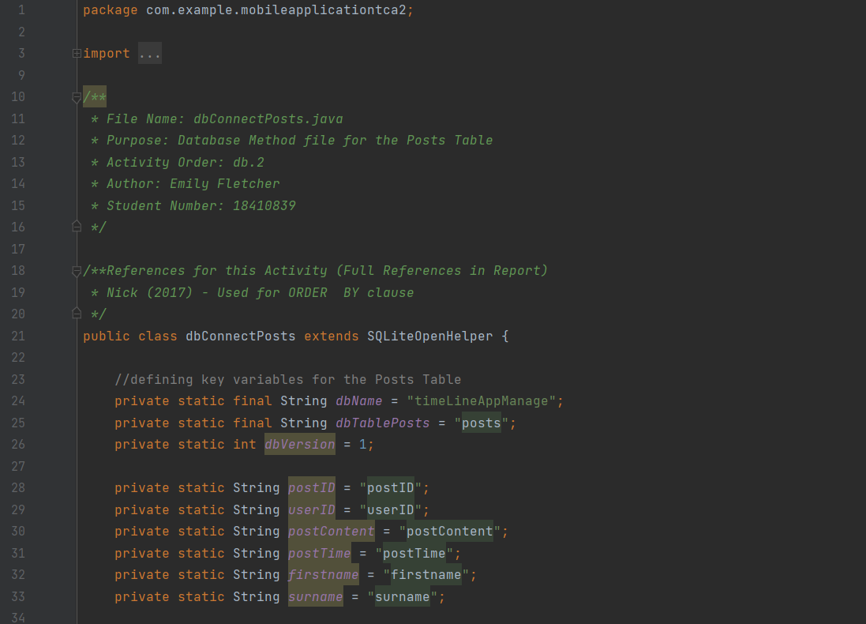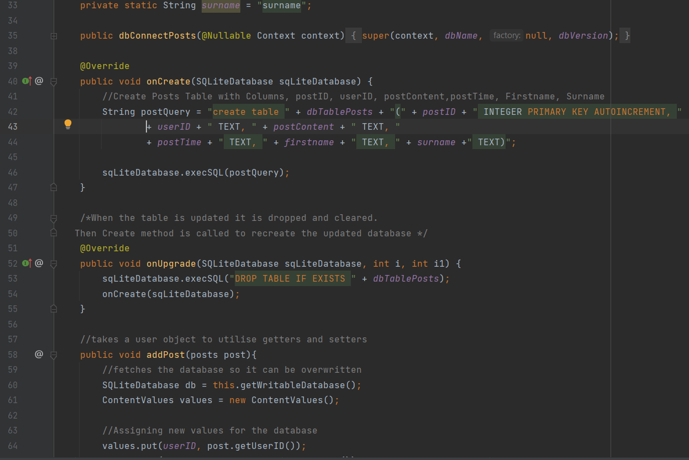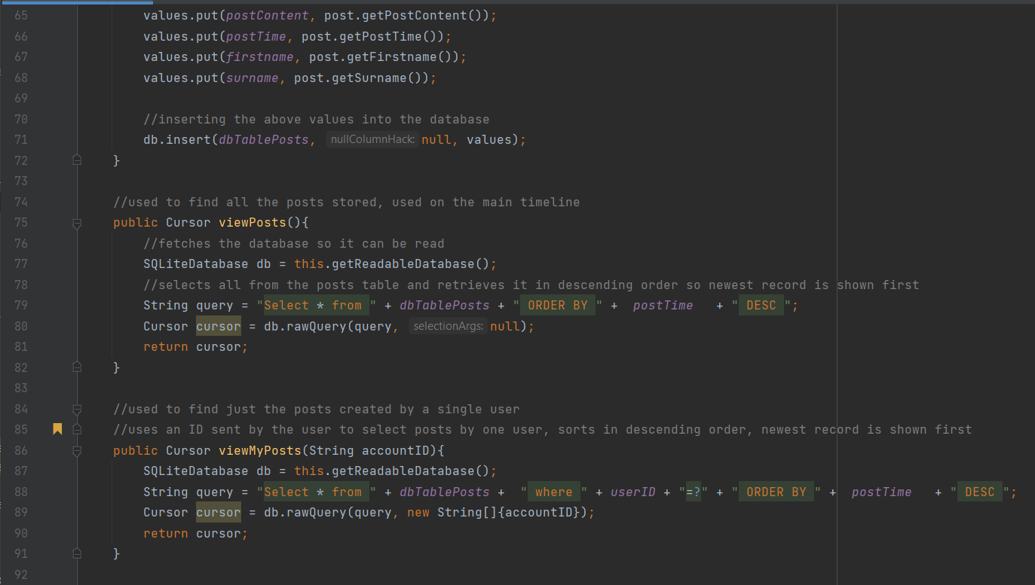

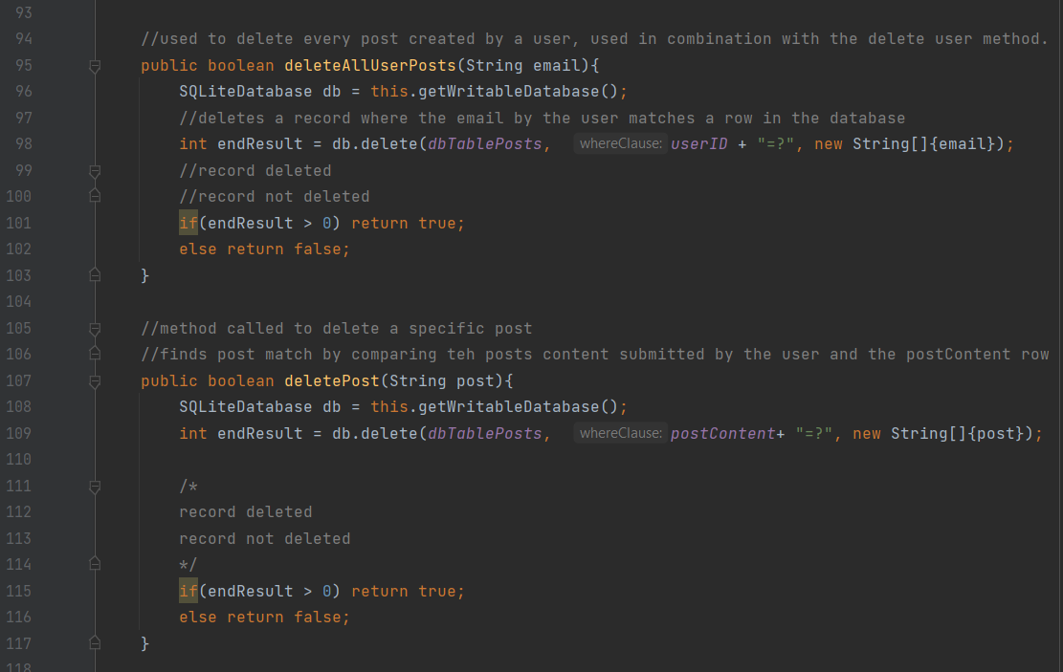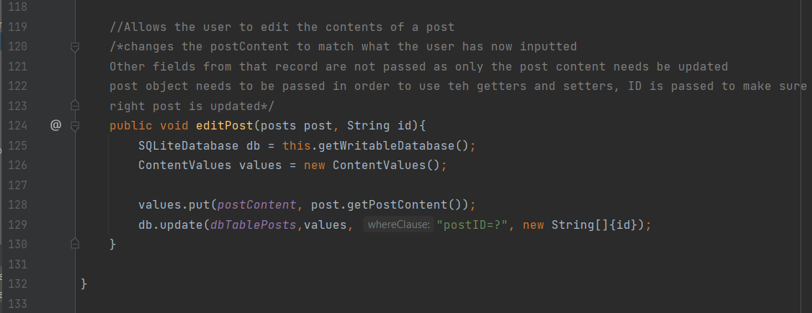

Activity Classes

Activity classes refer to all other java classes within the application. They are referred to as activity classes as they are directly linked to android activities within the application. They are going to be explained in alphabetical order.

adminHub

This activity acts as the home page for all admins after they successfully log in to the application. In the create method an array list is created and a method called view users is called, this method will fetch the details of all users within the database. Below is a try and catch statement that attempts to call another method called createFile. This method is used to create a text file on the user's device which can be used to store all the details of the users registered to the application.

The viewUsers method calls a method from the dbConnect class which returns all the users in the user's database. If there are no users found then a toast message is displayed telling the user that no users are found. If a record is used there is a string called record declared. This string gets each value from a row in the database and turns it into a string. It is then added to an array list. Then that array list is set onto a ListView object using an array adapter, this allows each record in the database to be seen in a list on the application.

The method below this, openDeleteUser, is used to open another activity on a button press.

The method underneath that is called createFile. This method gets the current device's file directory and creates a file that uses the directory and a filename that was defined at the top of the file. Once it is created a toast message is displayed so the user knows the file path has been created.

The saveValuesTo File method is called on a button press. When it is called it first calls another method called clearFile. This method is used to empty the file so that user records are not duplicated. The method calls the fetchUsers method from the dbConnect class to get all the users in the database. This is then added to a string in the same way as the viewUsers method. Then the file is overwritten with this string for each record. This then gives the user a text file with all the current users saved into it.

The clearFile method is the last in this class. When called this sets the current contents of the text file to an empty string, erasing all of the file's previous contents.

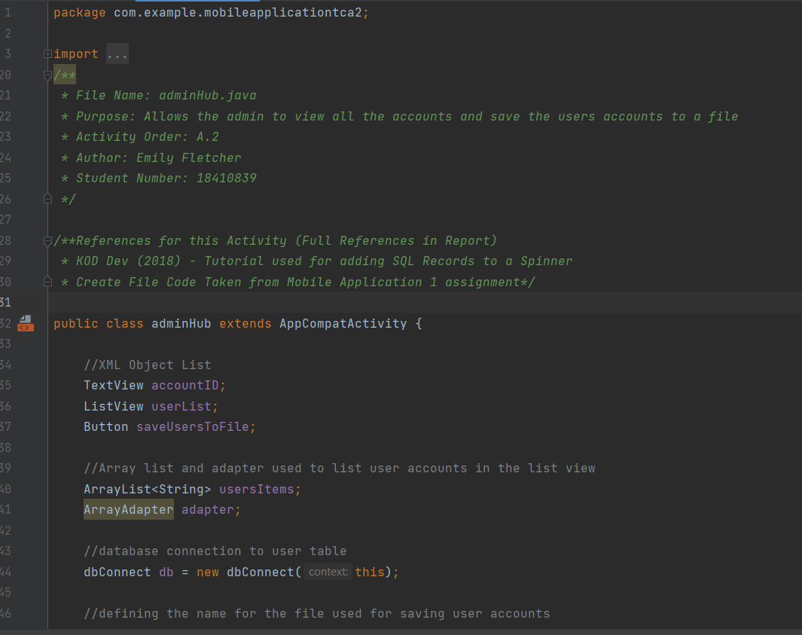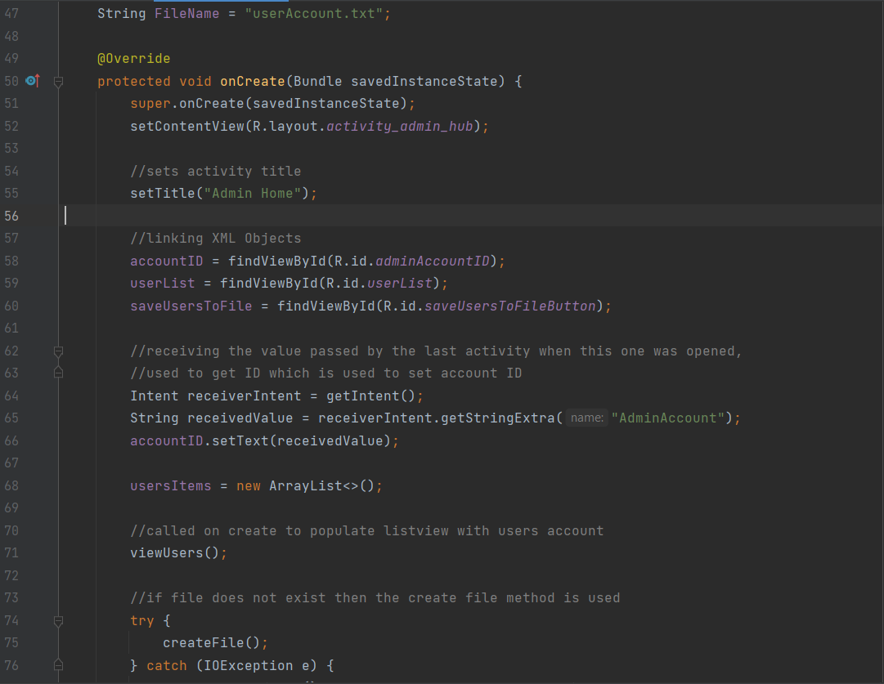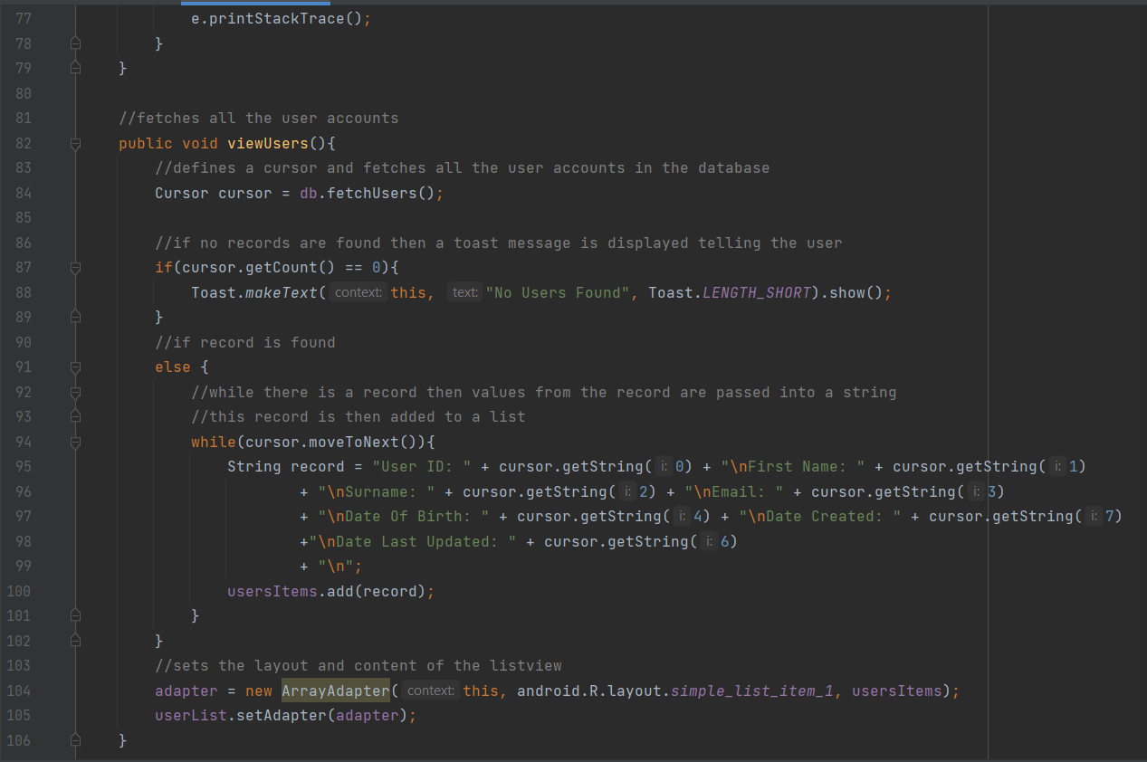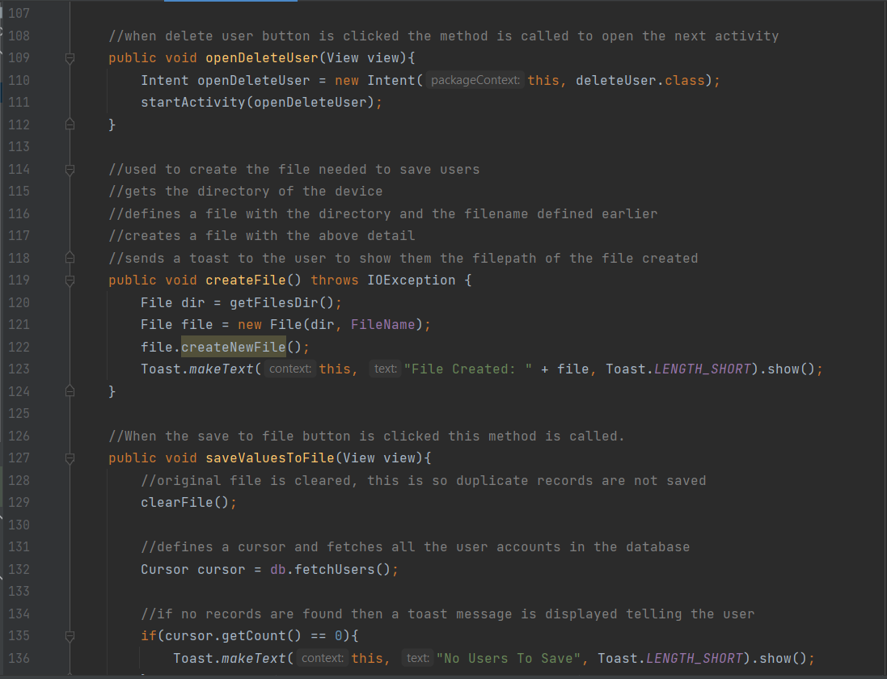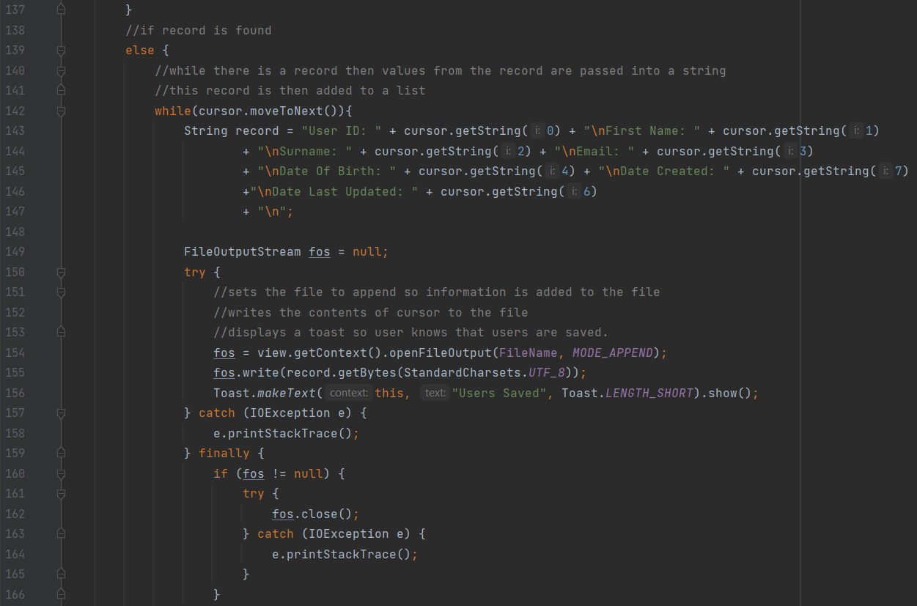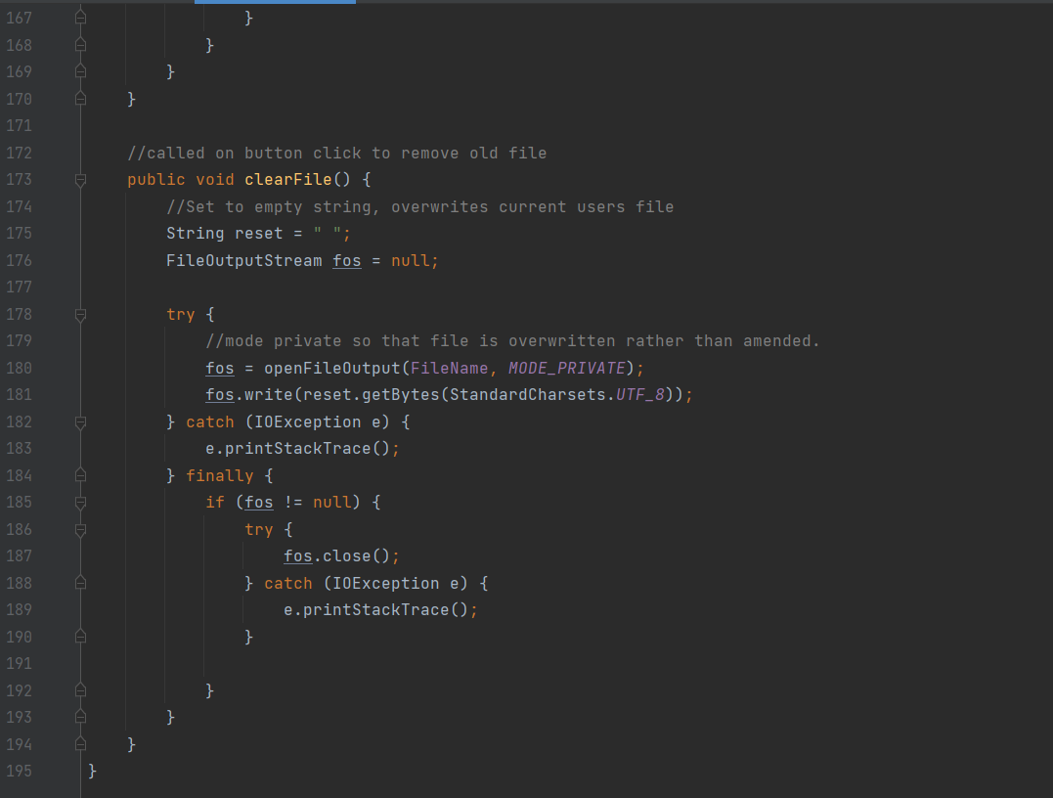

adminLogin and userLogin

These classes allow an admin and a user to log into the application. The author has merged both classes into the same explanation in the report as they are very similar in what they do and how they work. The only difference is that they call different database functions. The onCreate method sets a Click Listener on the adminLogin button. When this button is clicked the user's input is retrieved from the activity and assigned to two strings. If any of the fields are empty the user sees a toast message telling them that all fields are required. If all fields are filed then a new object is created with the user's input as its values. This is then passed to the relevant database to see if there is a record that has matching details with what the user has inputted. If there is a match then an if statement calls the next activity. If not then there is a toast message displayed saying that the login was not found.

The next method in the admin class is called openAdminHome, in the user class this is called openHome, in both of these methods the next intent is opened and the user account identification is passed to the next activity.

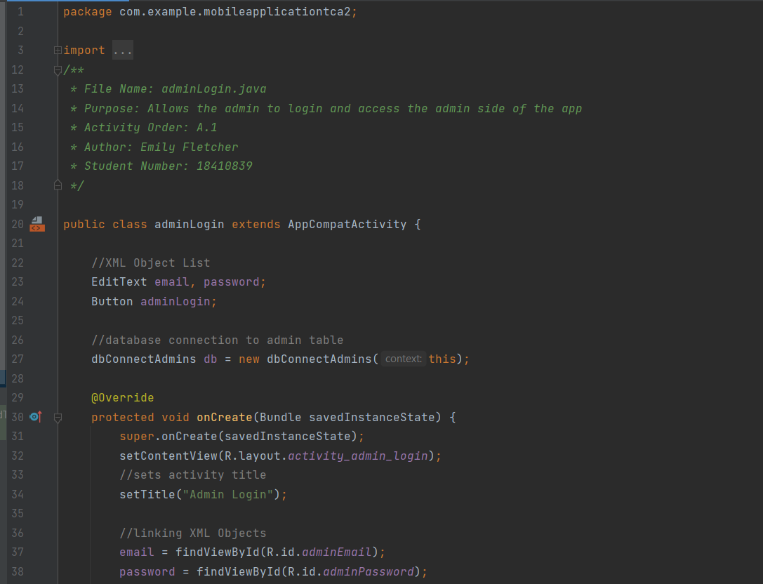

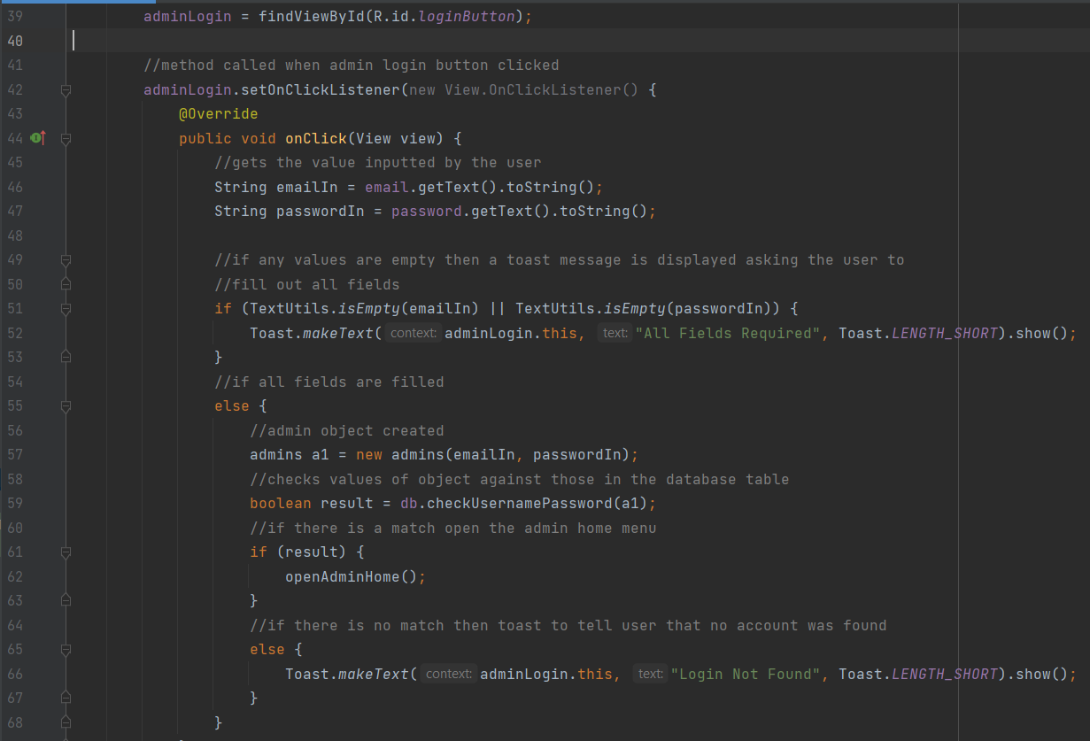

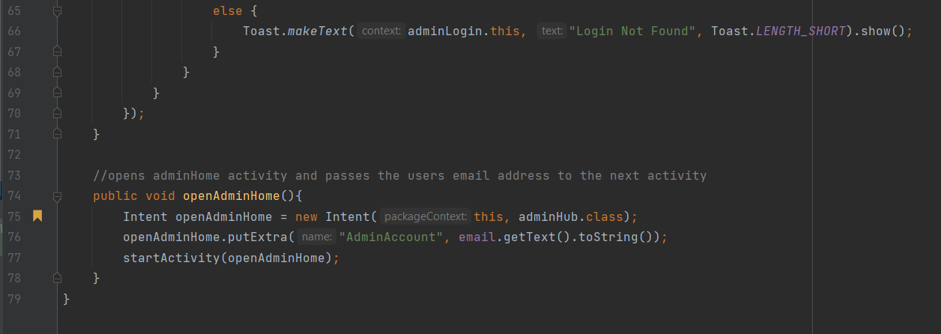

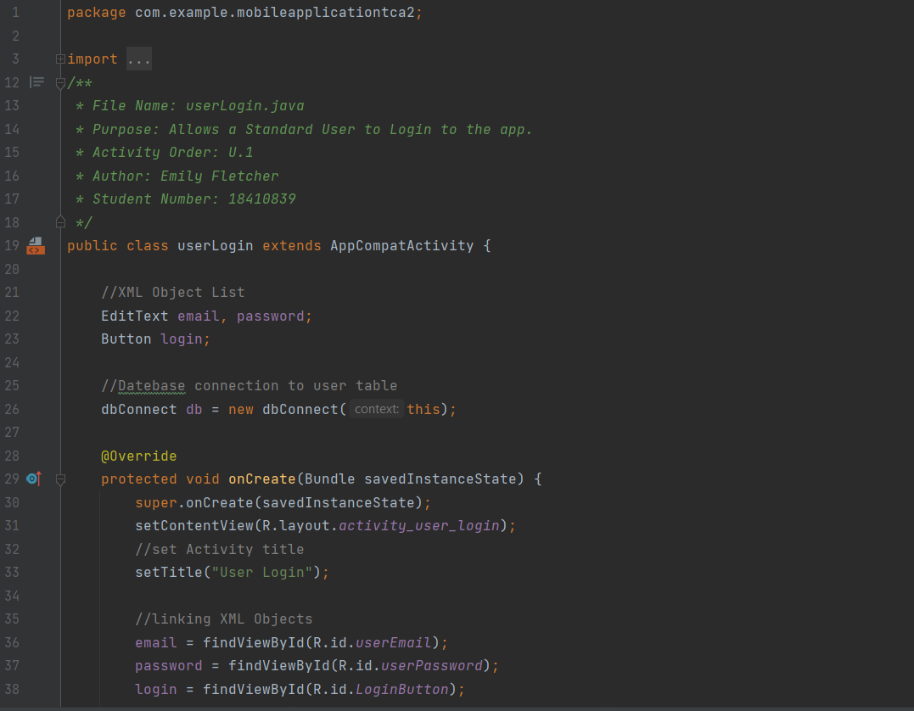

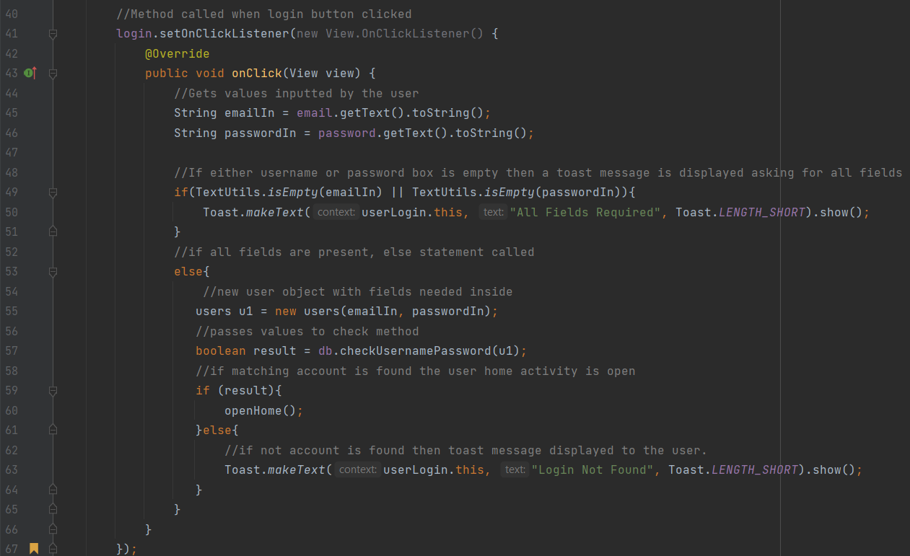

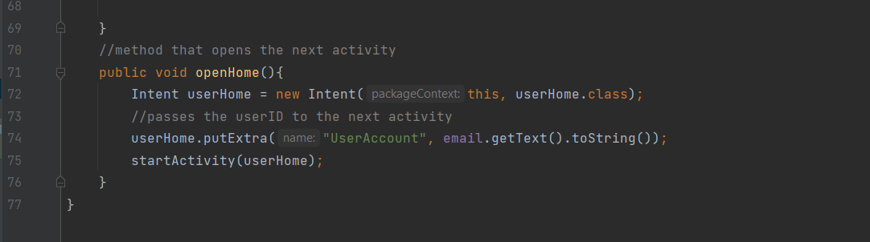

createNewPosts

This class is different from the others explained so far as it has two database connections. This is because this class requests data from two different tables. The first method in this class is the createDate method. This method is used to create a date that displays in the Americanised format of year, month, and day followed by the time posted. A timestamp string is returned from this method so other methods in the file can use it.

The create method receives data from the previous activity. The data passed from the previous activity is retrieved and is assigned as the userID. This is to simplify code as it is a lot simpler to pass one String from the database than re-query the database in the create method, especially as this string is needed to later fetch details in the create method.

Below this there is a call to a method called getNames, this is used to get the username for a welcome back message within the application. This passes the ID that was fetched from the previous intent to it.

Underneath this, there is an on-click listener for the create post button. When this button is clicked it checks what the user has inputted into the activity, If any of the textboxes are empty, a toast message is displayed telling the user that all boxes need to be filled.

If all the input fields are filled then the else statement occurs. This calls the create date method. This is called here to ensure the date created matches the time the user posts. The data the user inputted is then passed into a new post object. This object is then added to the post database using the addPost method. A toast message is displayed that lets the user know the post has been created.

The last method in this class is the getNames method, this method was mentioned earlier as it is called in the onCreate method. This method takes the accountID value and calls the fetchUser method that is linked to the user’s database. This get’s the poster's first and surname and sets the welcome back message to their name. This is important as this is later fetched when the user submits a post so that the user's post has a name linked to it.

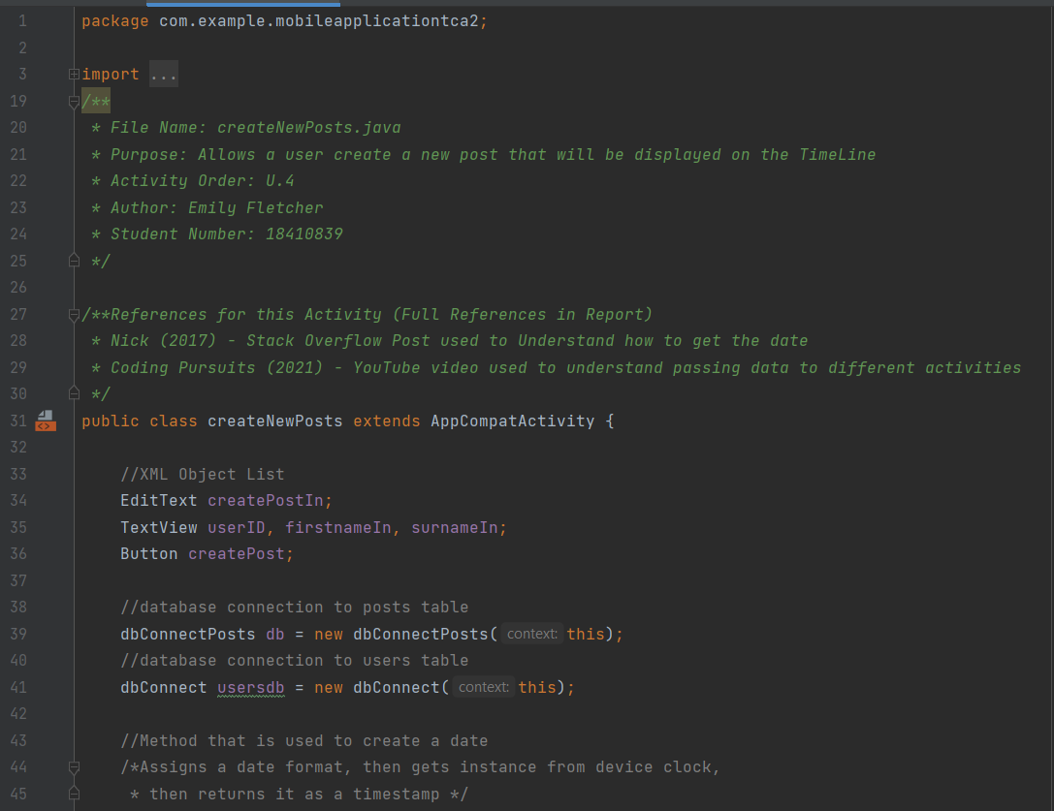

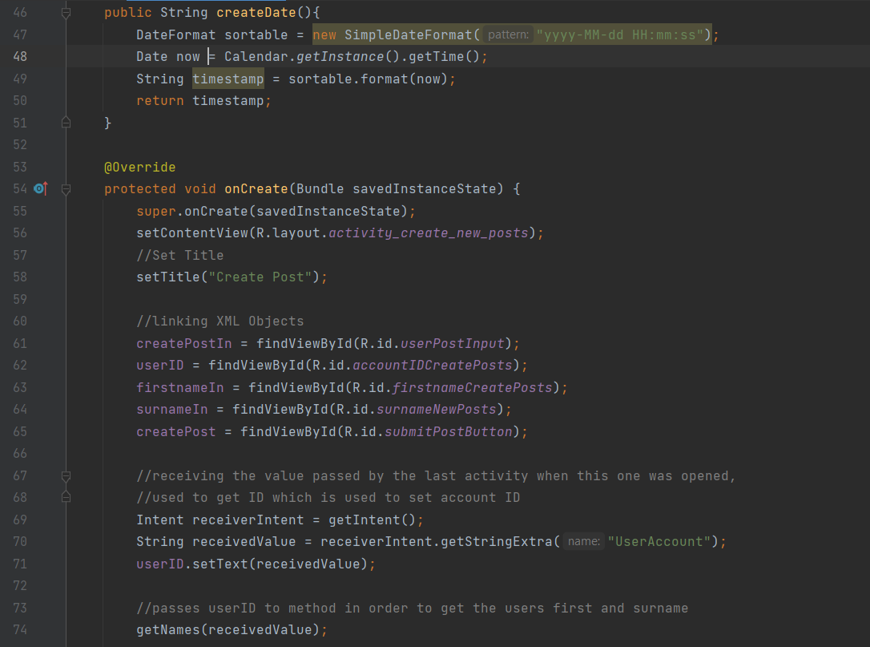

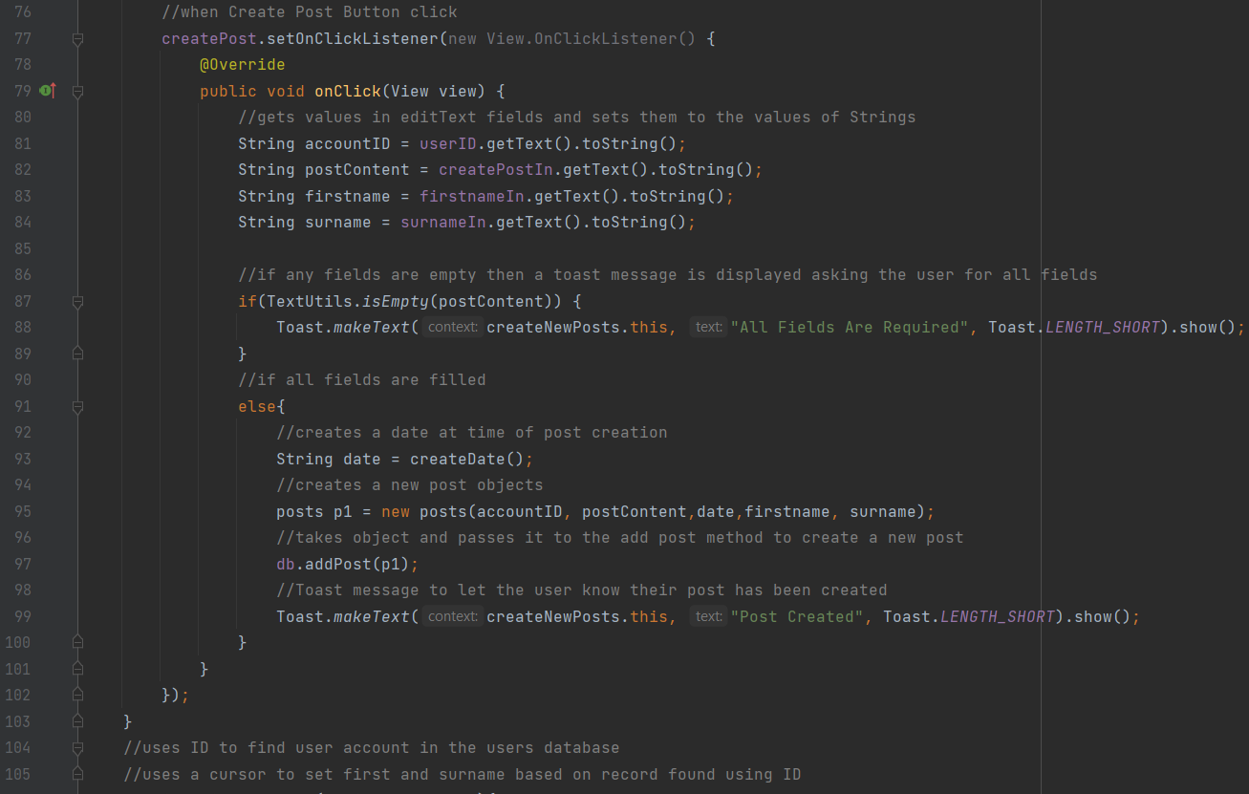

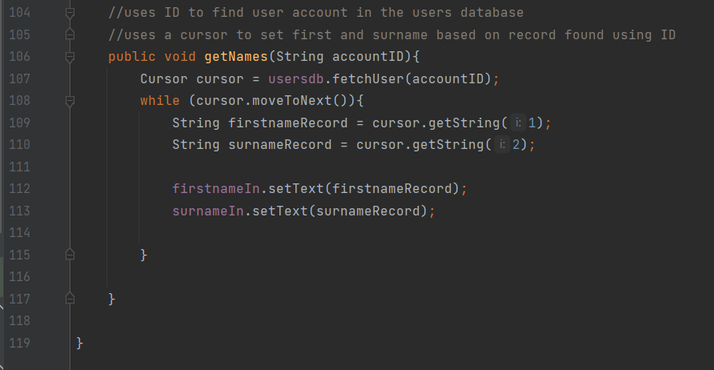

deleteUser

This activity is used by the admin when they want to delete a user. At the top of the class is two database connections. This is because when a user is deleted all their posts also need to be deleted.

In the onCreate method, a spinner is set up. This spinner will display all the standard user accounts that are registered with the system. To populate the spinner the viewUsers method is called after this.

Underneath this is an onClick method for the delete button. When this is clicked the current value is fetched by the Spinner. This is then passed to a database function called deleteUser in the user's database, which deletes a user from the user's database that has a matching id to the one passed. Then the same ID is passed to the posts database this is then used to find all the posts that have that usersID, it then deletes all those posts. If the user has been deleted then a toast message is displayed telling the user the account is gone, then, another toast message is displayed if all the user accounts have been deleted relating to that.

In the last part of the method is the code that live updates the activity. This code works by closing the current activity and reopening the application on the current activity which fetches the up-to-date information from the database. Transitions are removed from this so this is seamless, and the user does not know the application has been closed and reopened again.

Below are two autogenerated methods, these are needed for the spinner, however, they are not used so they remain empty.

The last method in this class is the viewUsers method. This works the same as the viewUsers function in the adminHub, except the final result is added to a spinner rather than a list view.

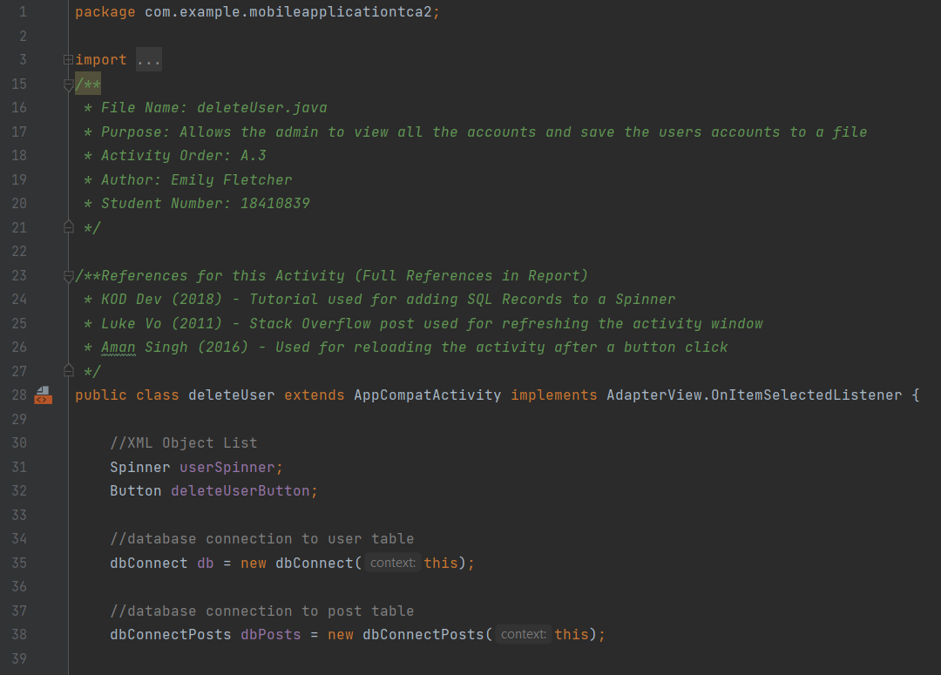

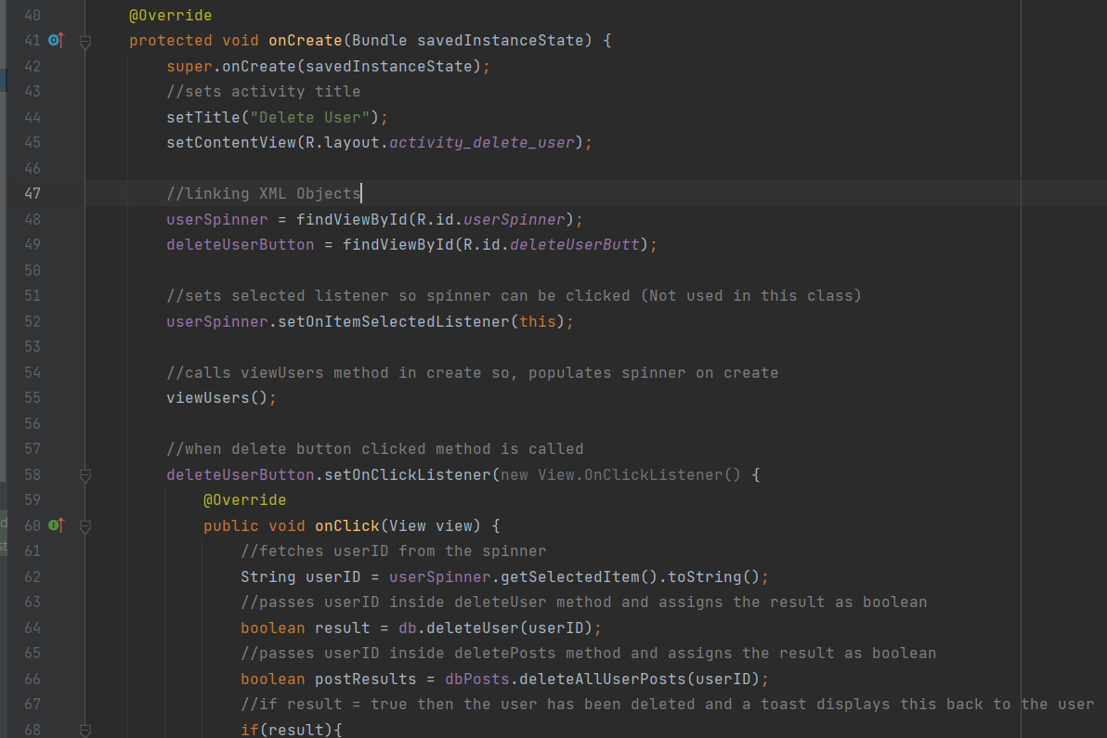

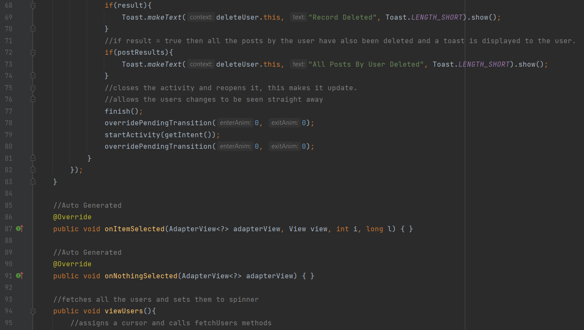

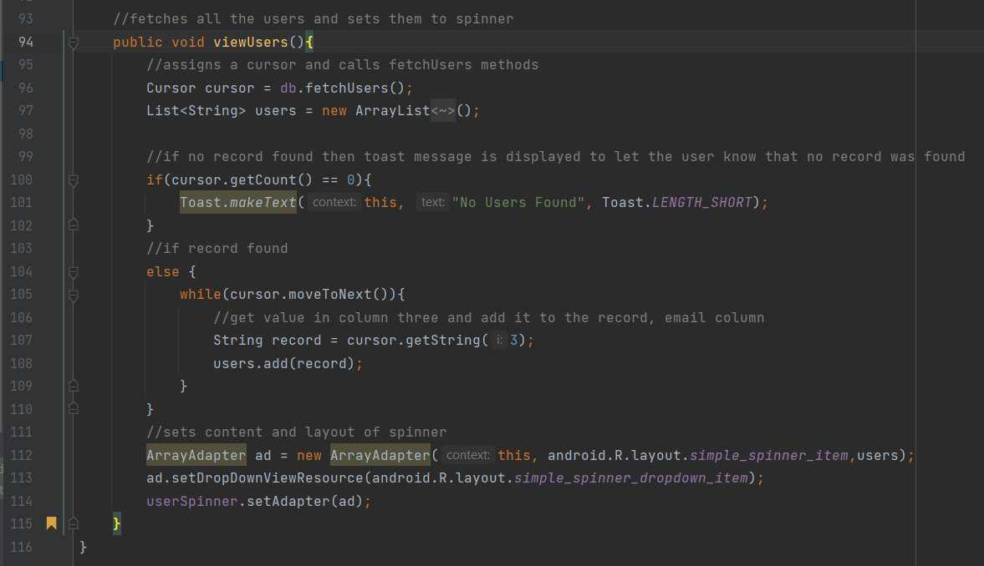

MainActivity

The main activity is unique compared to other classes in this application. This is the first activity that opens when the user launches the activity. This activity acts as a splash screen, so the application doesn’t seem like a sudden start. This is also good for accidental openings of the app as it allows the user to understand what they have opened before the app starts. This works by having a handler in the OnCreate method. This handler delays the opening of the next activity by a timer set by me. This current delay is set for three seconds. After three seconds the application opens the next activity.

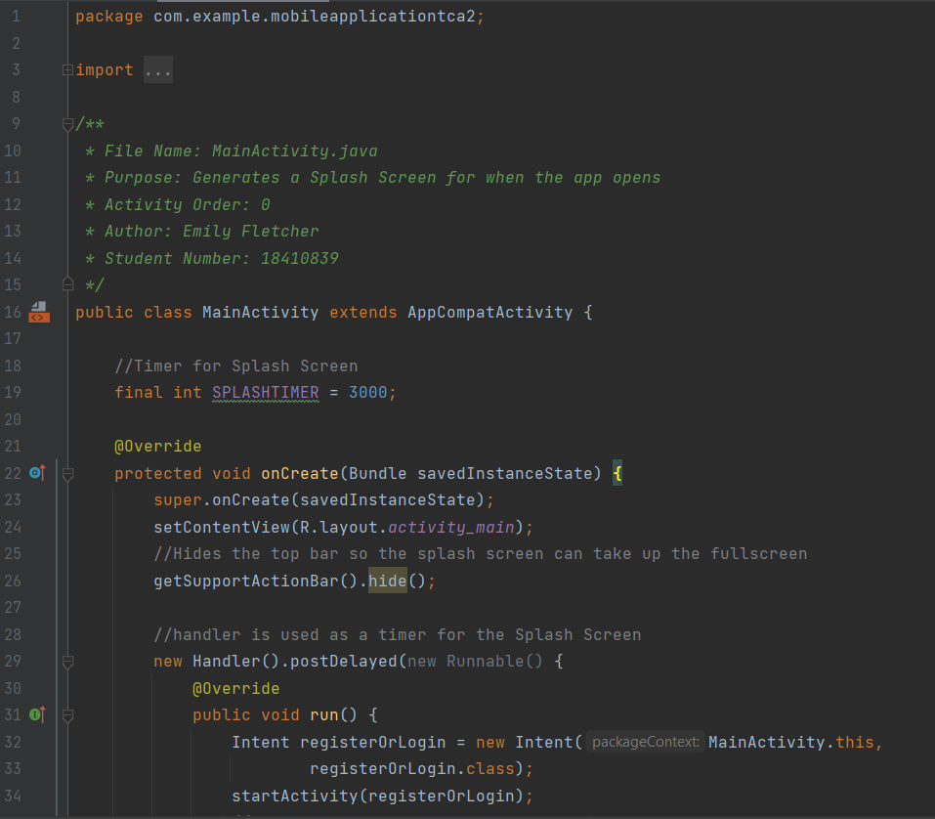

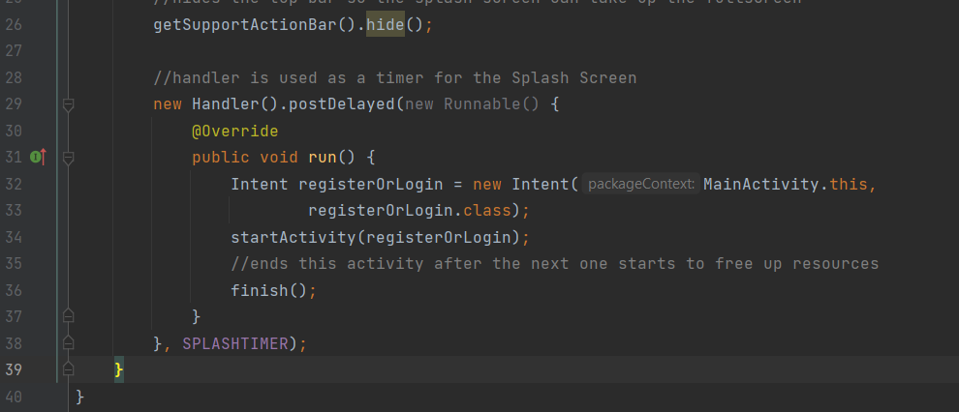

myAccount

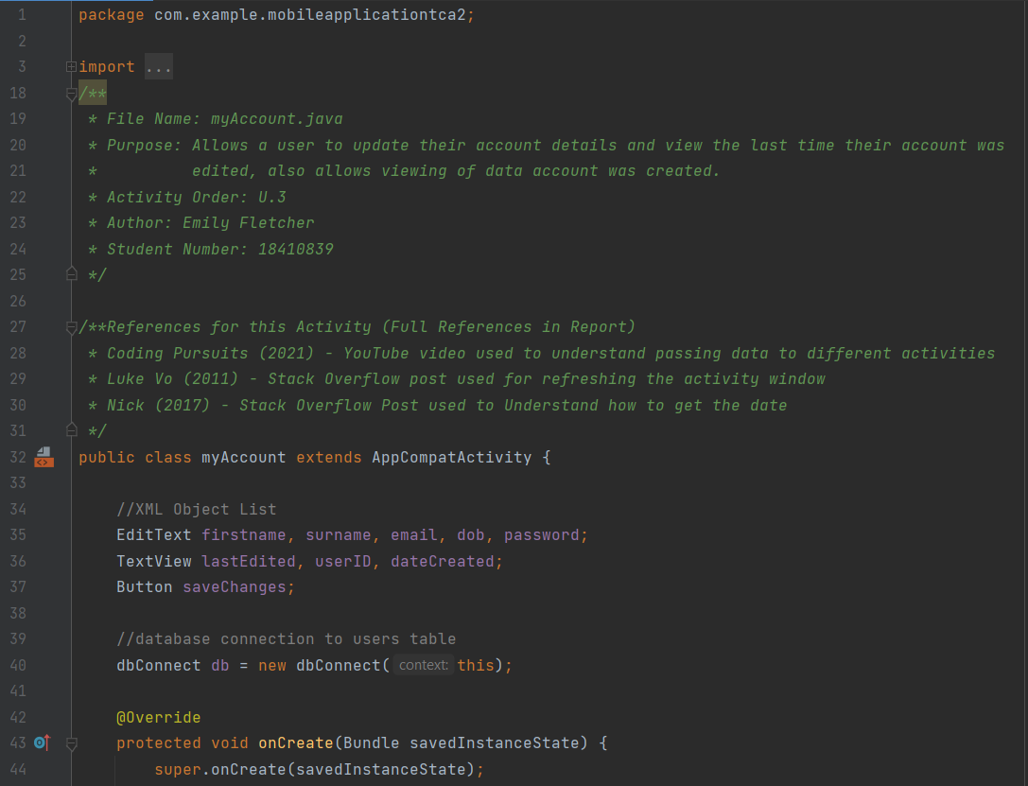This method is used to get all the current logged in user's details. This works similarly to some of the other classes in the way it gets data. The accountID is received from the previous activity and passed to this one. This is then passed to a method called viewData, which retrieves all the details from the current account using the user's database, these are then set to all the text fields so they are prefilled with account details. When the saveChanges button is clicked the user's input is retrieved from the activity and if all the fields are filled the date is created for the update date part of the database, this and all the records entered by the user are then pushed to the database and overwrite the selected row. The activity is then refreshed so all the details shown are up to date using the same method as explained previously. Below are the methods for creating a date and viewing the data in the record. These have already been explained in other classes.

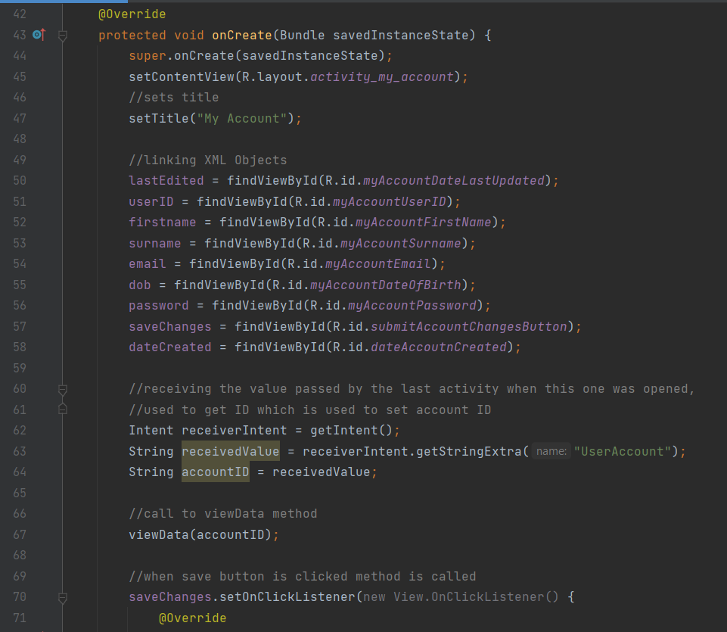

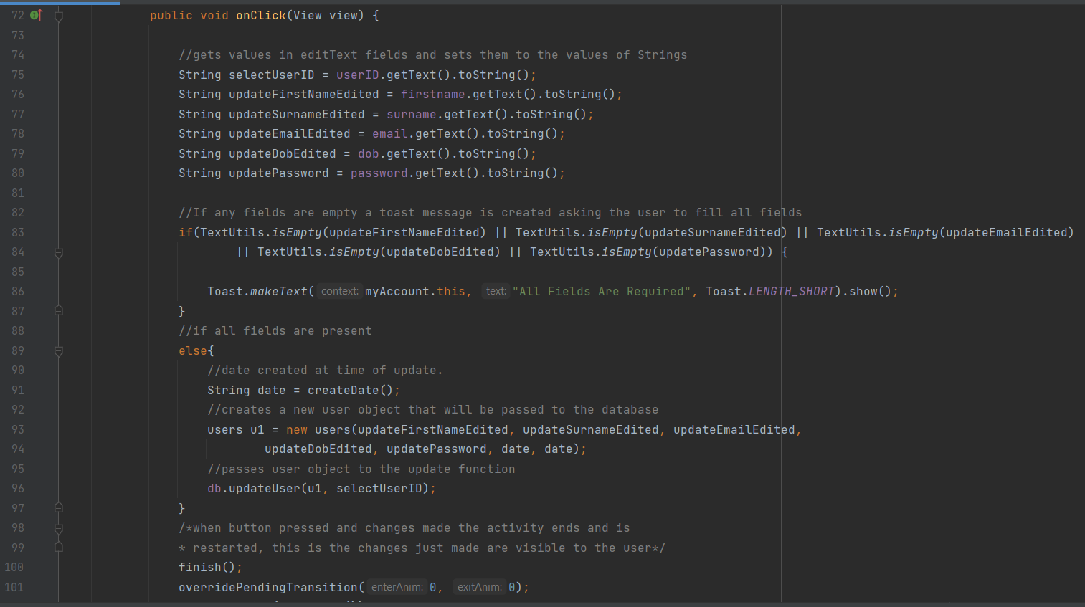

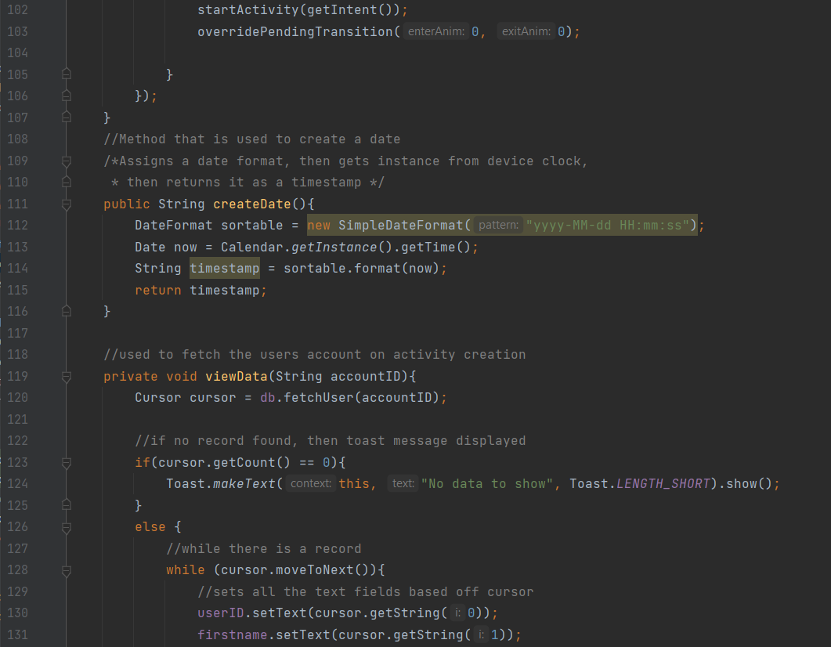

myTimeline

this activity features two database connections as all the posts are needed as well as the user's detail. OnCreate this class received the accountID from the previous activity as well as defining an array list. The viewData method is called and the getNames method is called with the accountID passed into it. Both of these methods have been explained in another activity. There is a method in this class called startUpdater. This is used to automatically refresh the posts on the timeline. It starts a timer based on a device tick that is one minute. Every time a minute passes the list view with the posts on it clears and the viewData method is called again. This allows new posts to be fetched automatically and the timeline to be updated. Below are two methods called onResume and onPause. These are used to restart the timer and release the timer when it is not in use. This allows resources to be released when they are not in use and reduces the slow down of the application.

Underneath this is two activity calls that are linked to buttons. These open the delete post and edit post activities.

Lastly is the getNames method, this was explained previously.

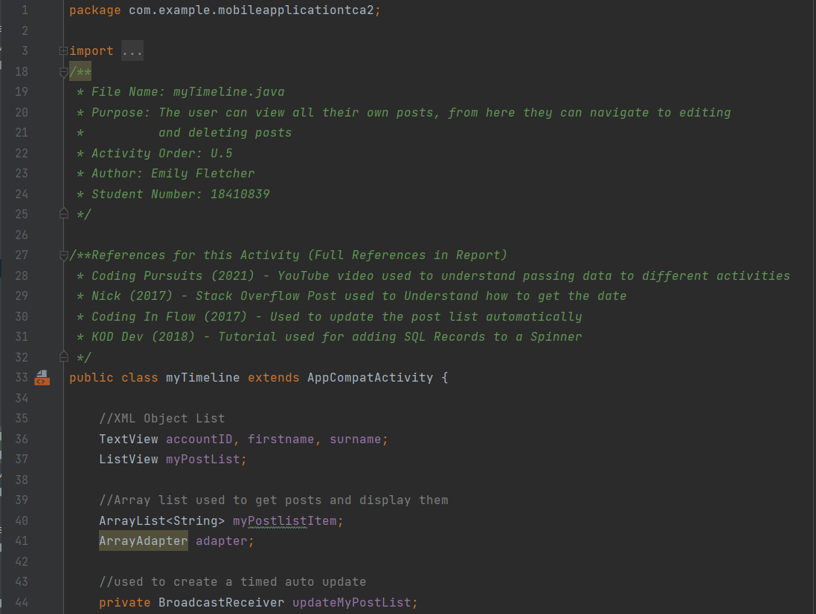

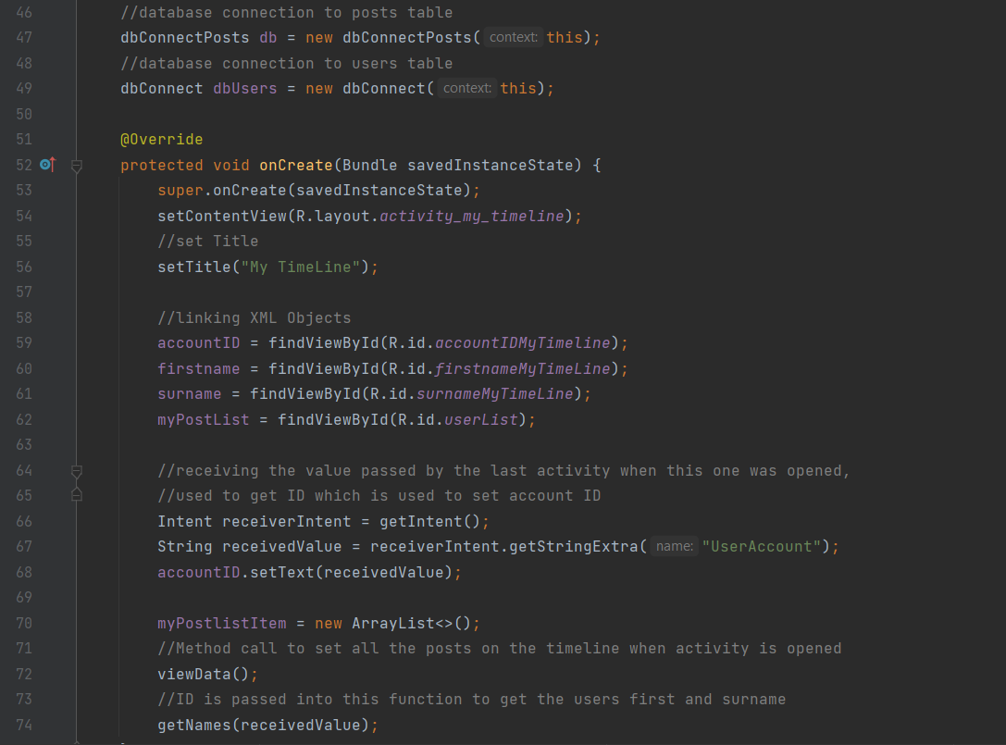

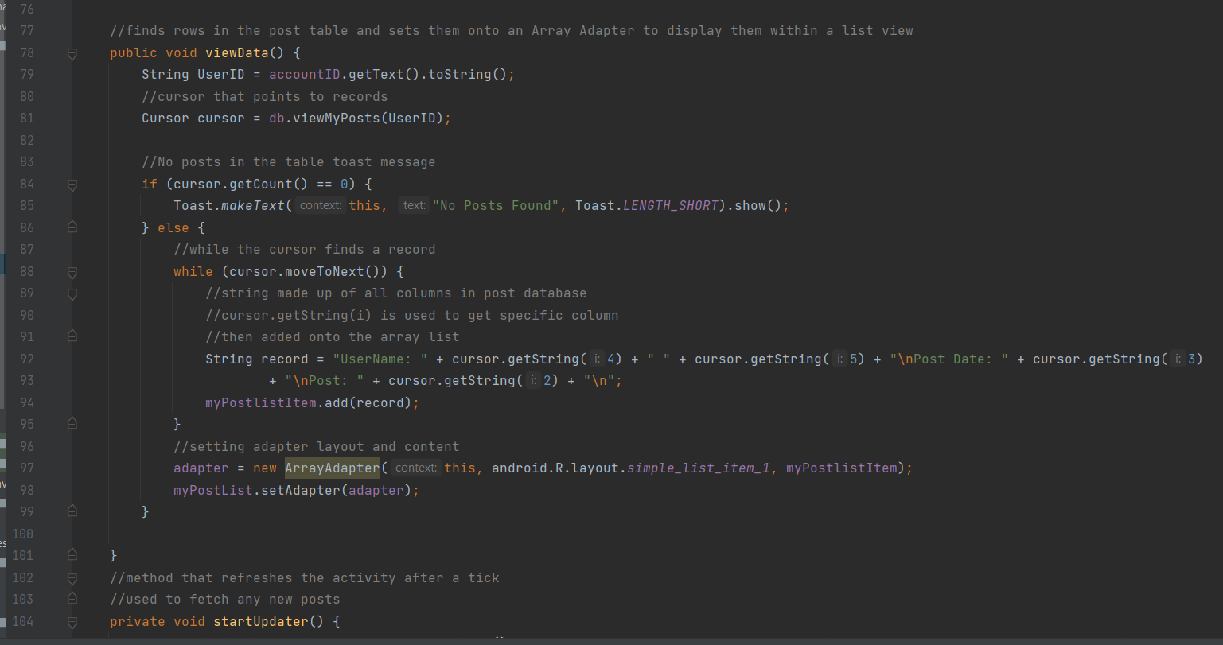

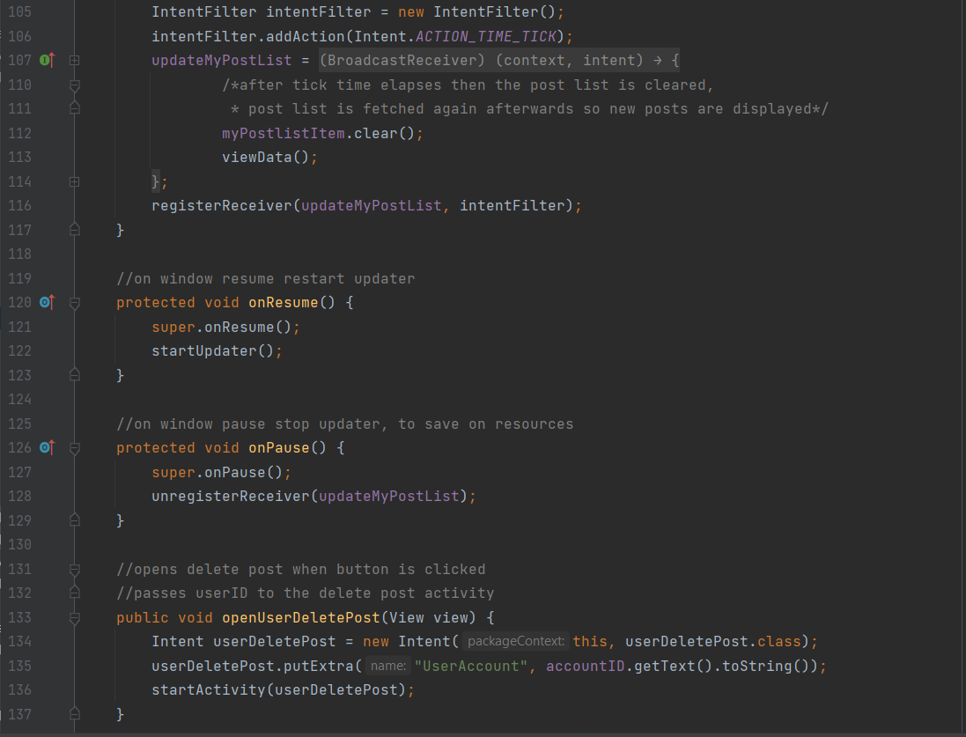

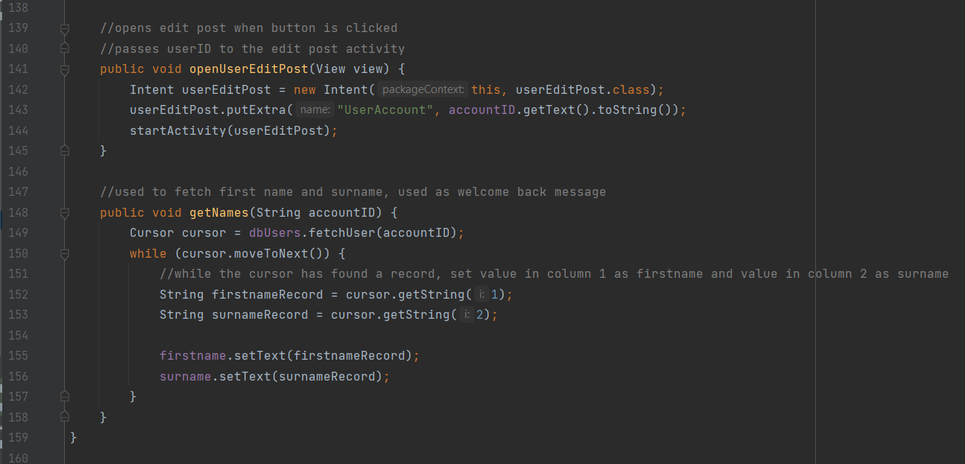

registerNewAccount

This activity is used to create new accounts. This works by taking the user's input in the same way that posts are created. When the createAccount button is clicked all the data entered by the user is passed to the addUser function including a date. The date is created using the createDate method that has been used in other activities.

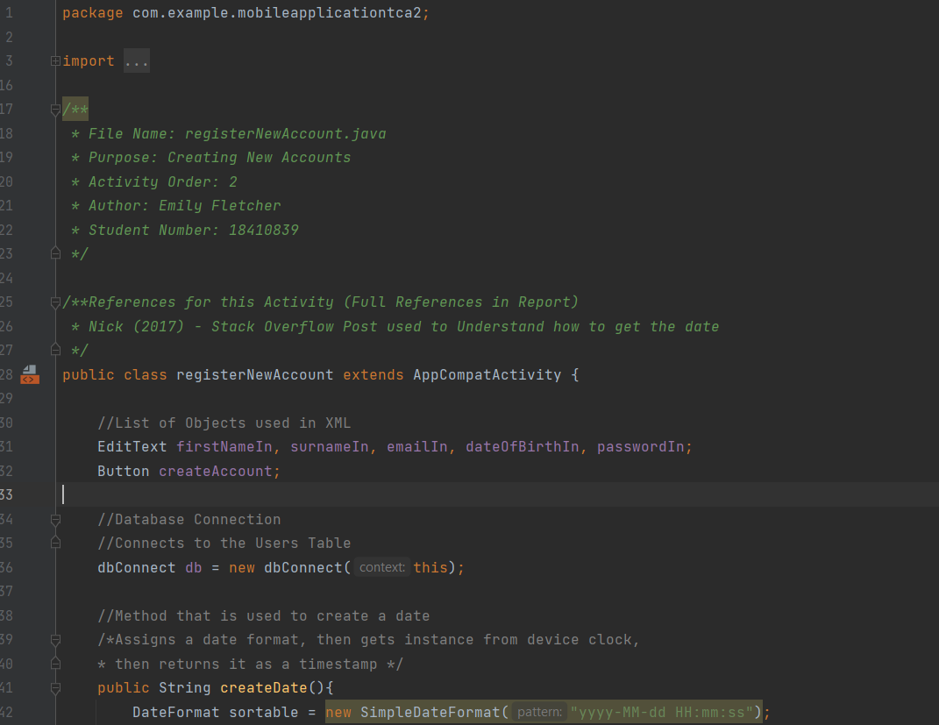

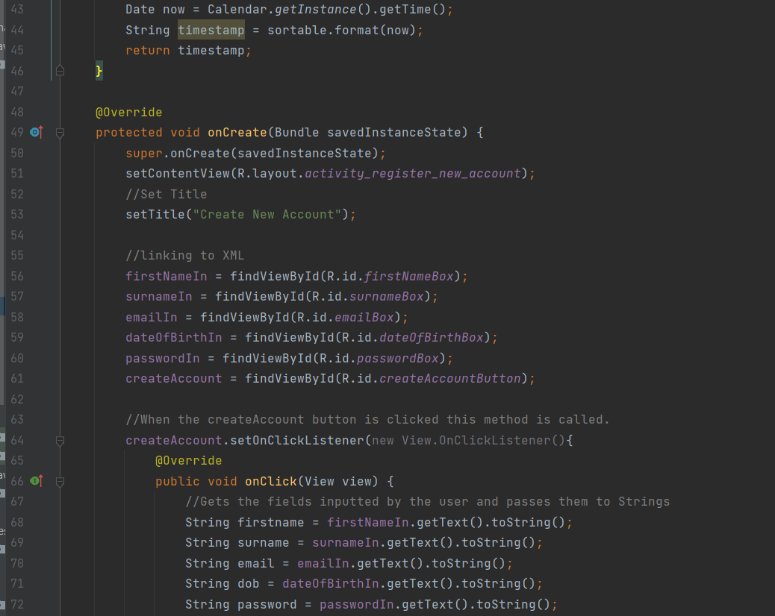

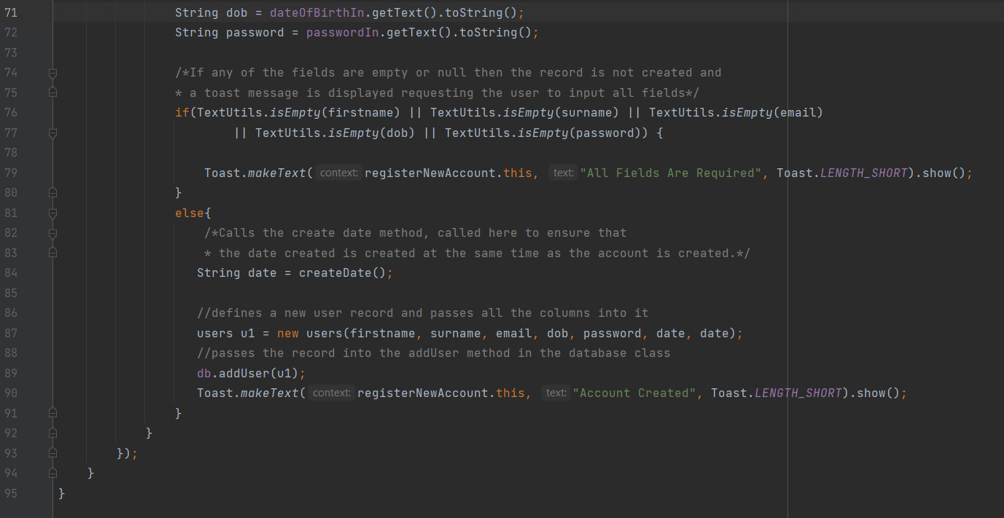

registerOrLogin

This activity is a simple navigation activity. This activity is opened after the splash screen, it allows the user to login into the app or register a new account. There are four methods in this activity. The first is the onCreate method. The other three are methods that open on a button press.

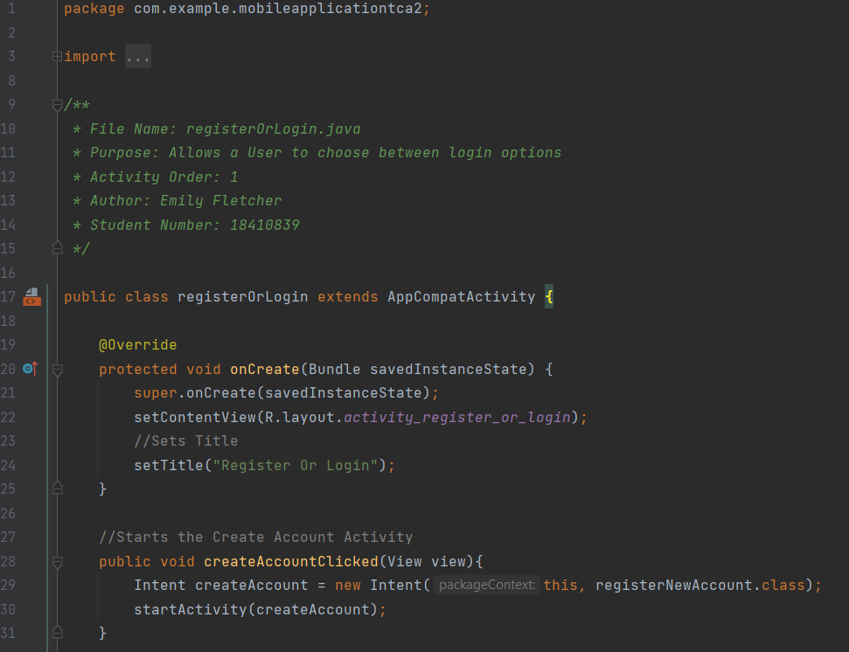

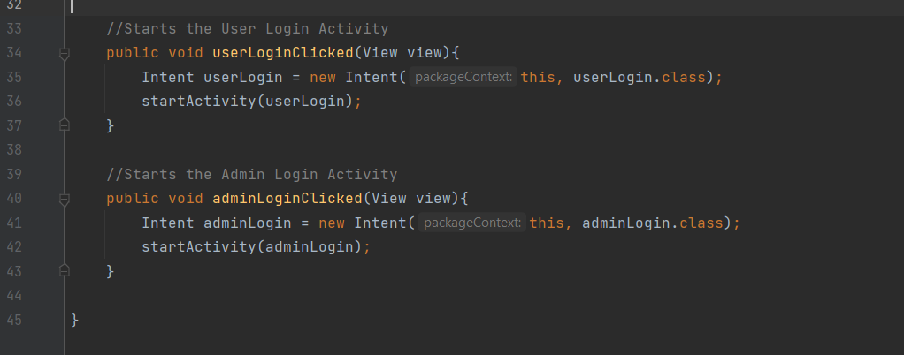

userDeletePost

This activity has no new unique methods that haven’t been explained. When the activity is created. The userID is received from the previous activity, this is used to set the account number on the activity. Then the viewPosts method is called to get all the user's posts and set them on a spinner. When the delete button is pressed the onClick method is called. This passes the current post in the spinner into the deletePost method which removes the post from the database. IF a post is deleted then the activity is refreshed by opening and closing it as explained earlier.

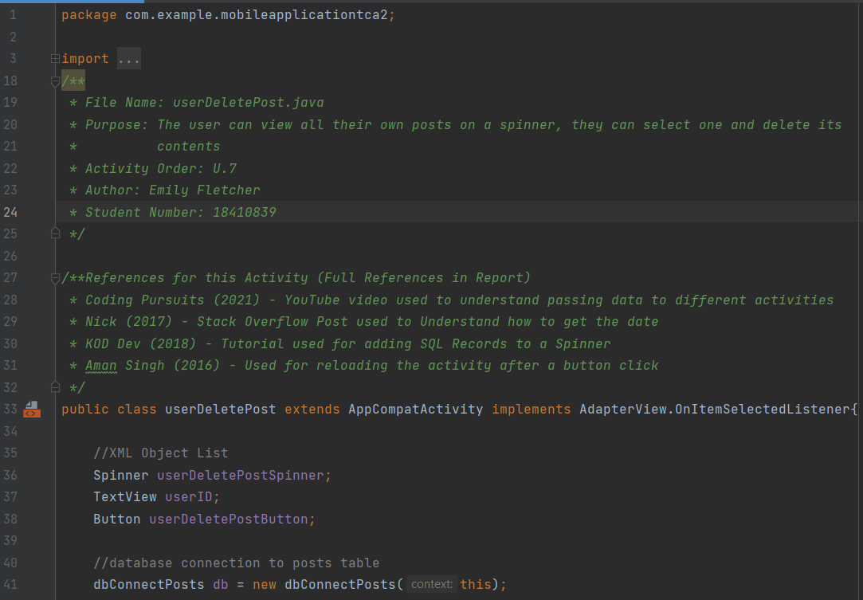

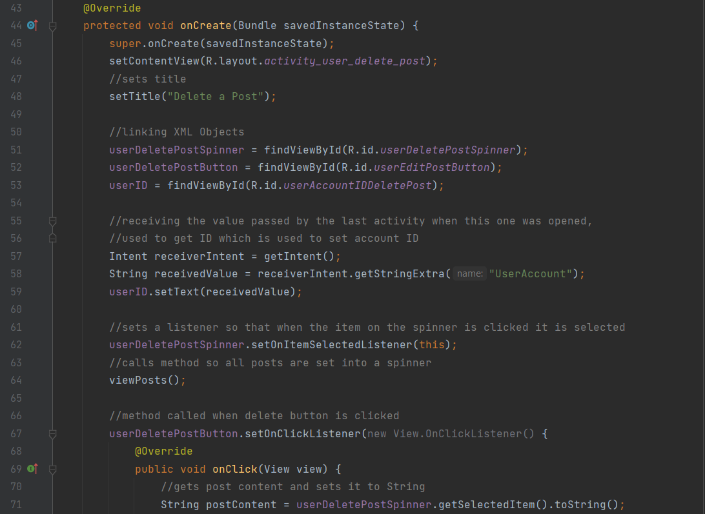

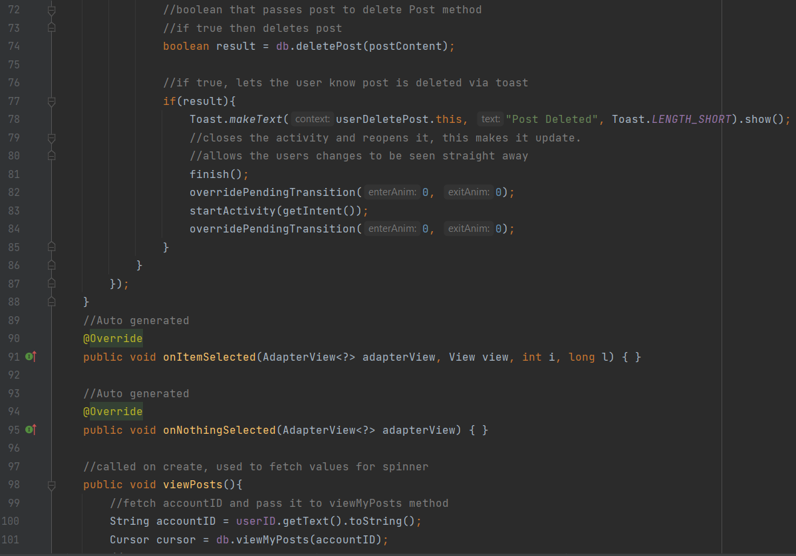

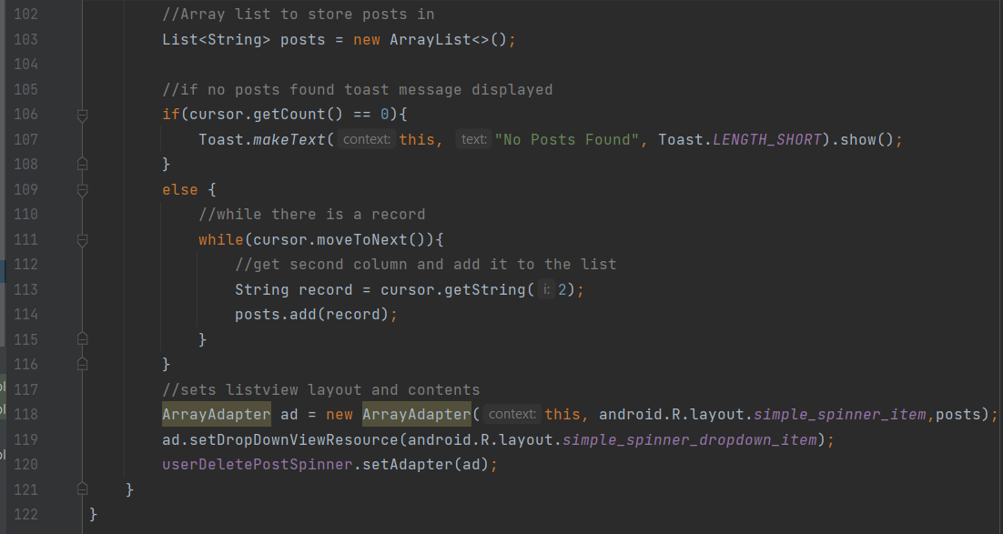

userEditPost

this class has very similar code and methods to the myAccount class as it allows the user to edit records in the database. However, the only main difference is that this class queries the posts database rather than the user database and uses a spinner. The methods in this class are, onCreate and viewPosts, there is a clickListener and an onSelect listener. When a post is selected from the spinner, which is assigned in the onCreate. The selected post is loaded in the text boxes below it, this allows the user to see the full details. Then, the onClickListener is linked to the edit button. When the edit button is clicked the usersInput is received and the record is overwritten. There are also some empty methods. These are required by the spinner and array adapter so they must remain, even though they have nothing inside of them.

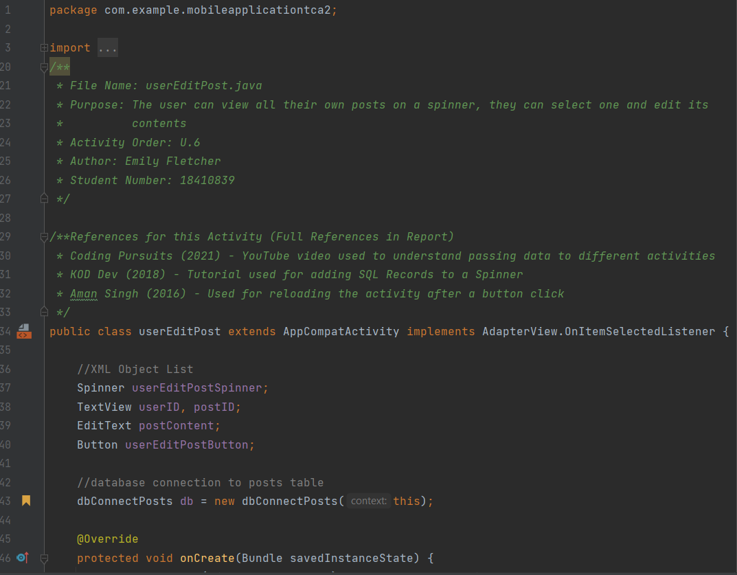

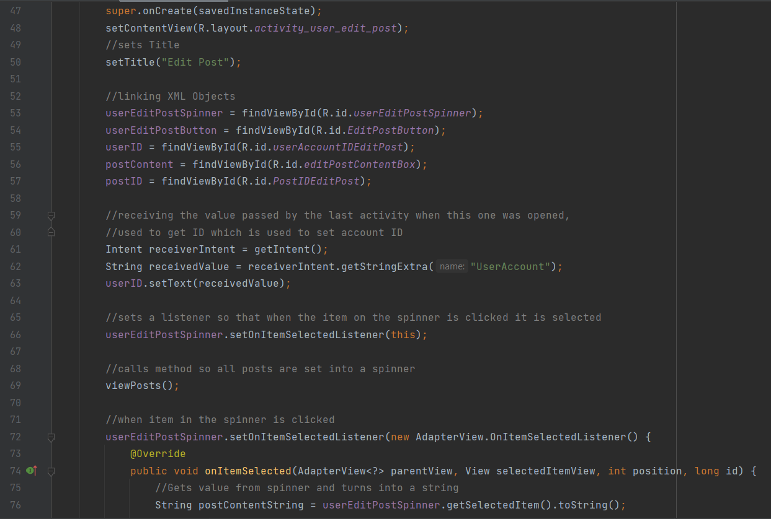

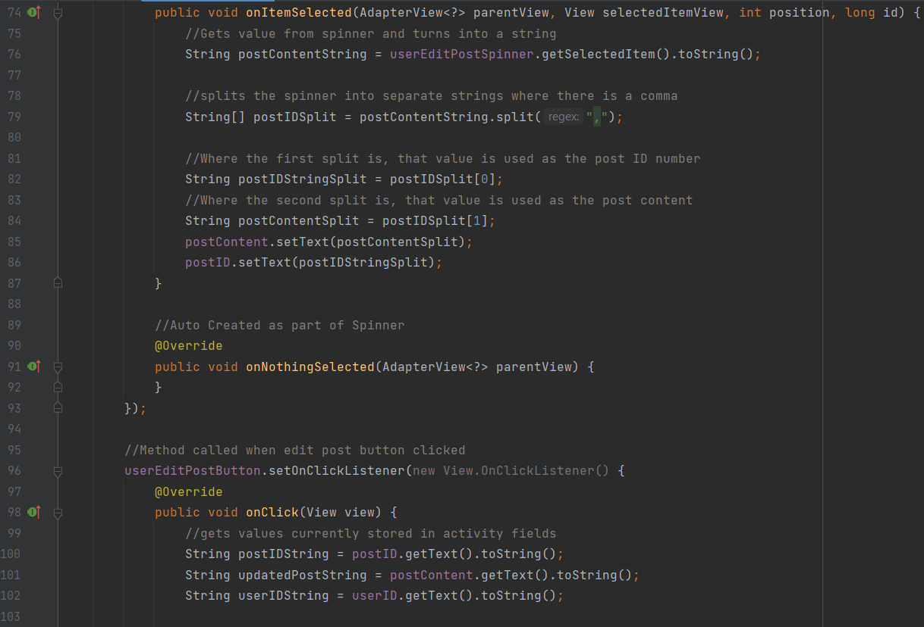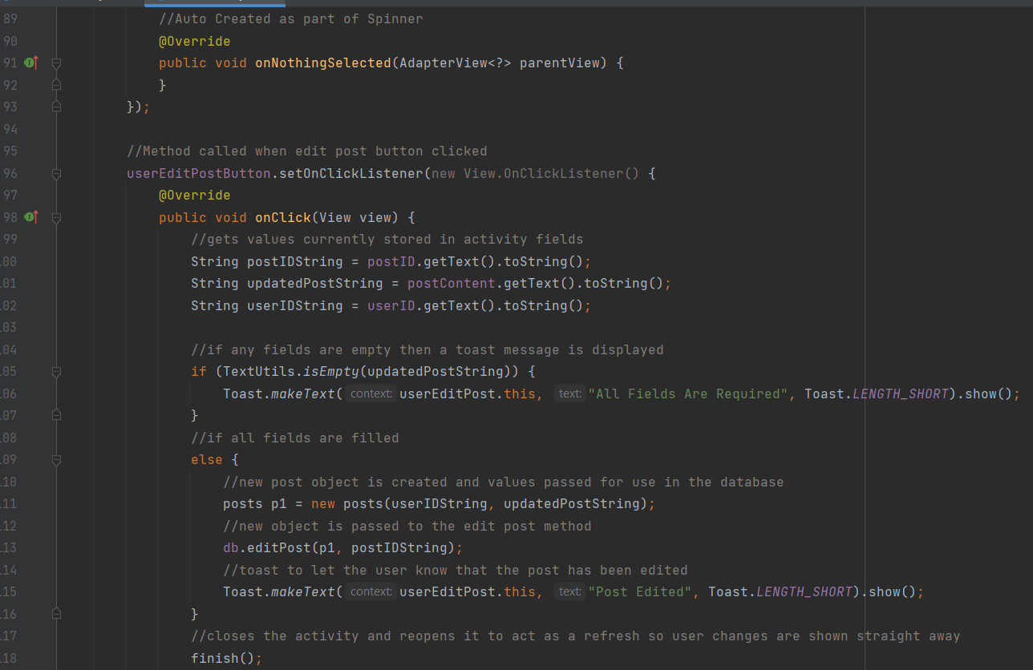

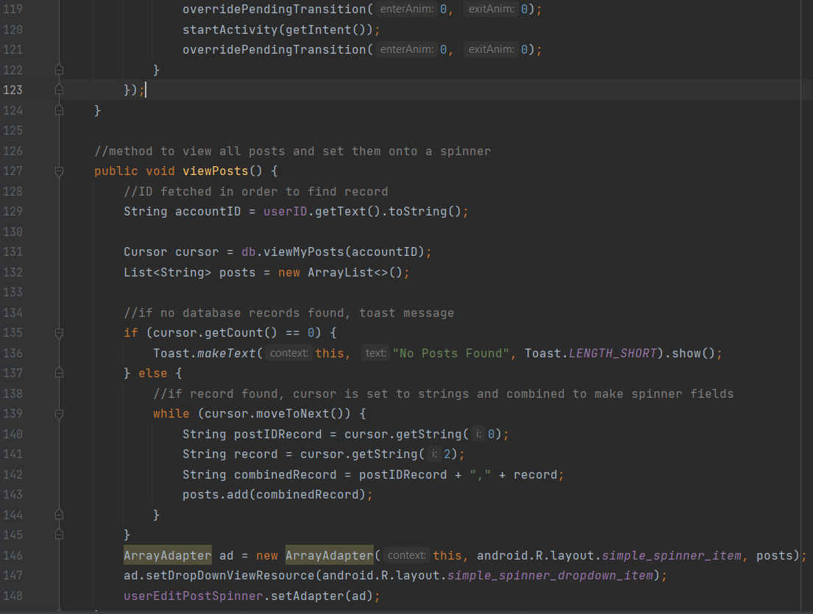

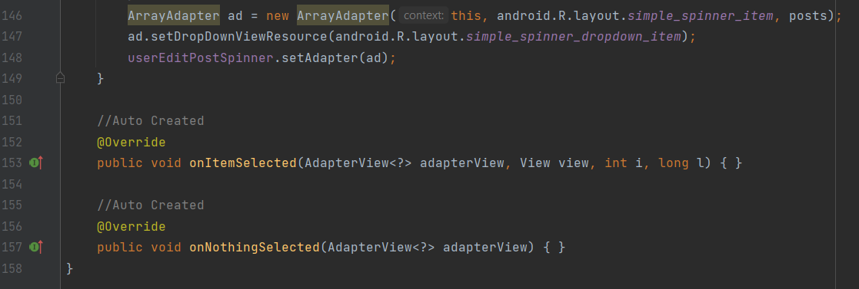

userHome

This activity is what the user is greeted with when the user logs in. When the activity is started it receives a userID from the previous activity, this is then passed to the getNames activity, and then viewData is called. This fetches data from the database and assigns it to a listView so the user can see each post created. There are three methods in this class that start new activities, These allow the user to open their timeline, create posts and view all their account details. The updater code that was used in myTimeline is also used here.

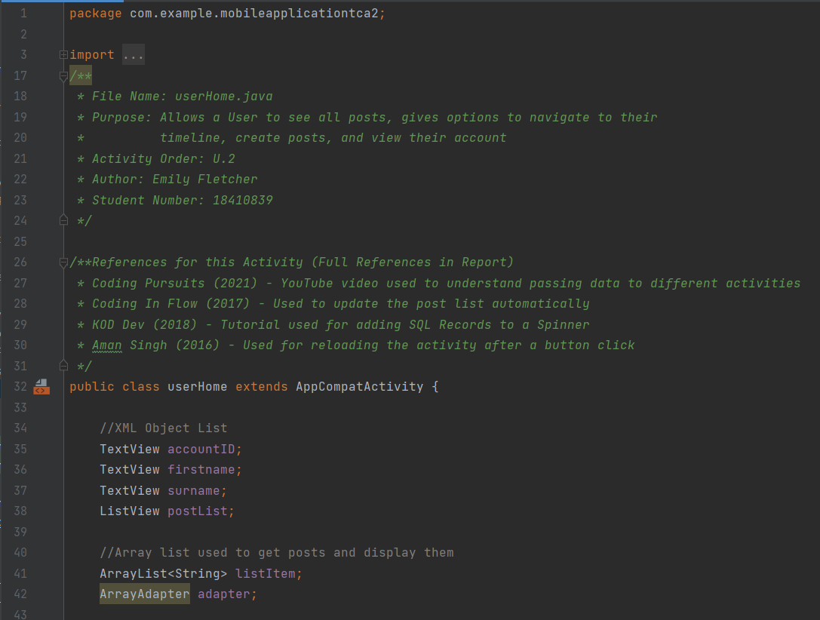

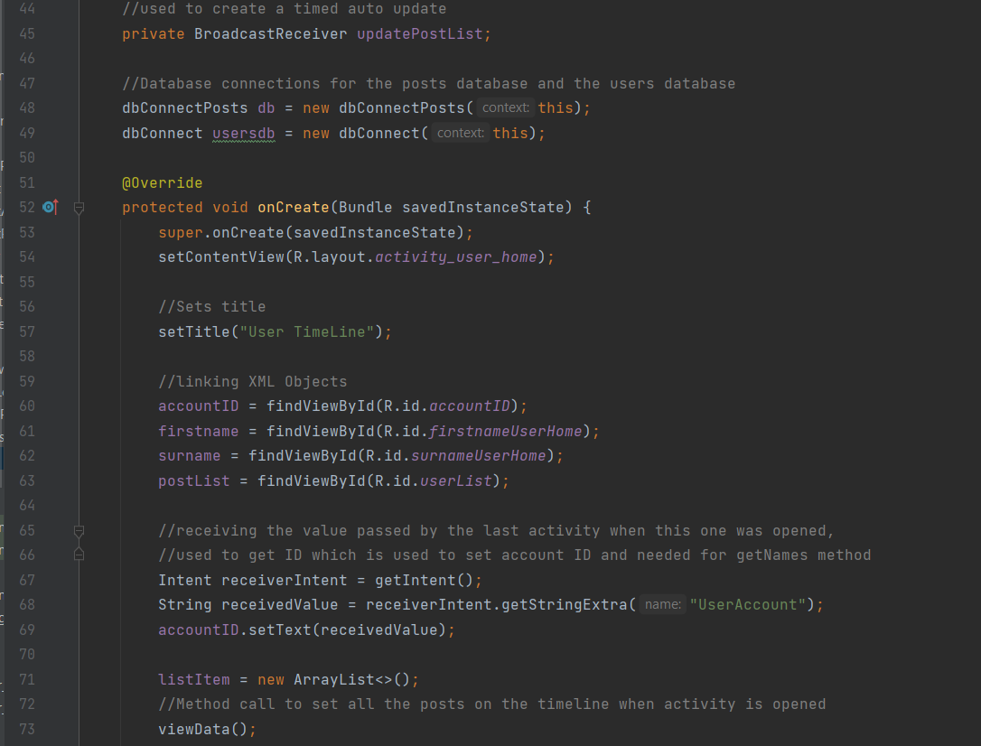

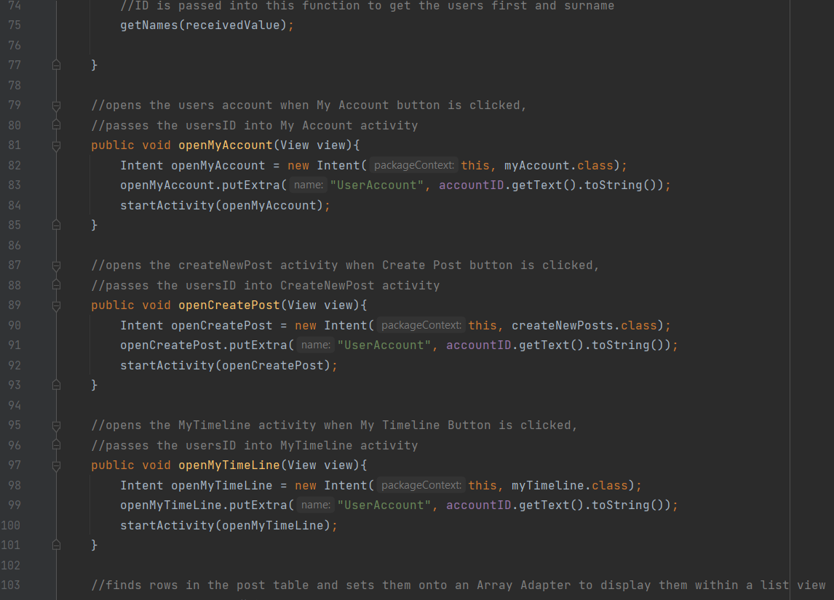

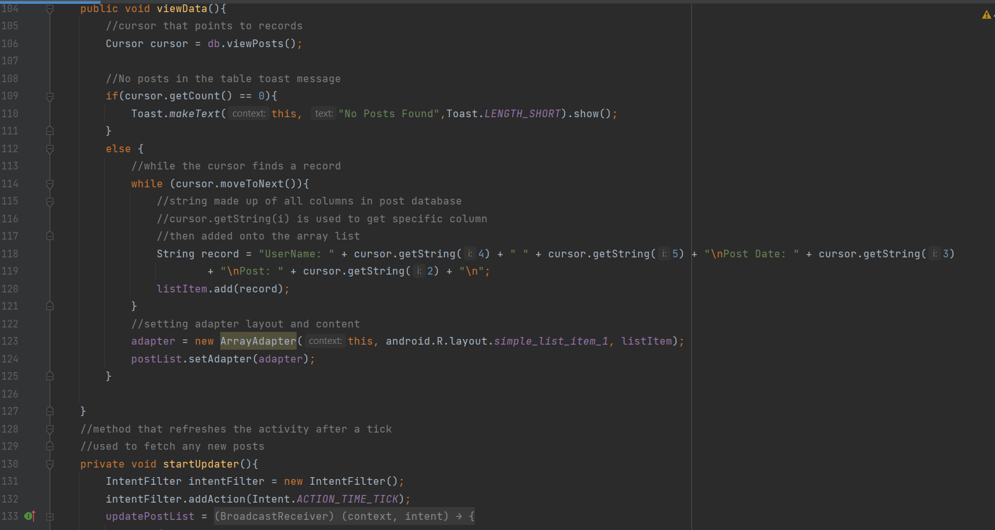

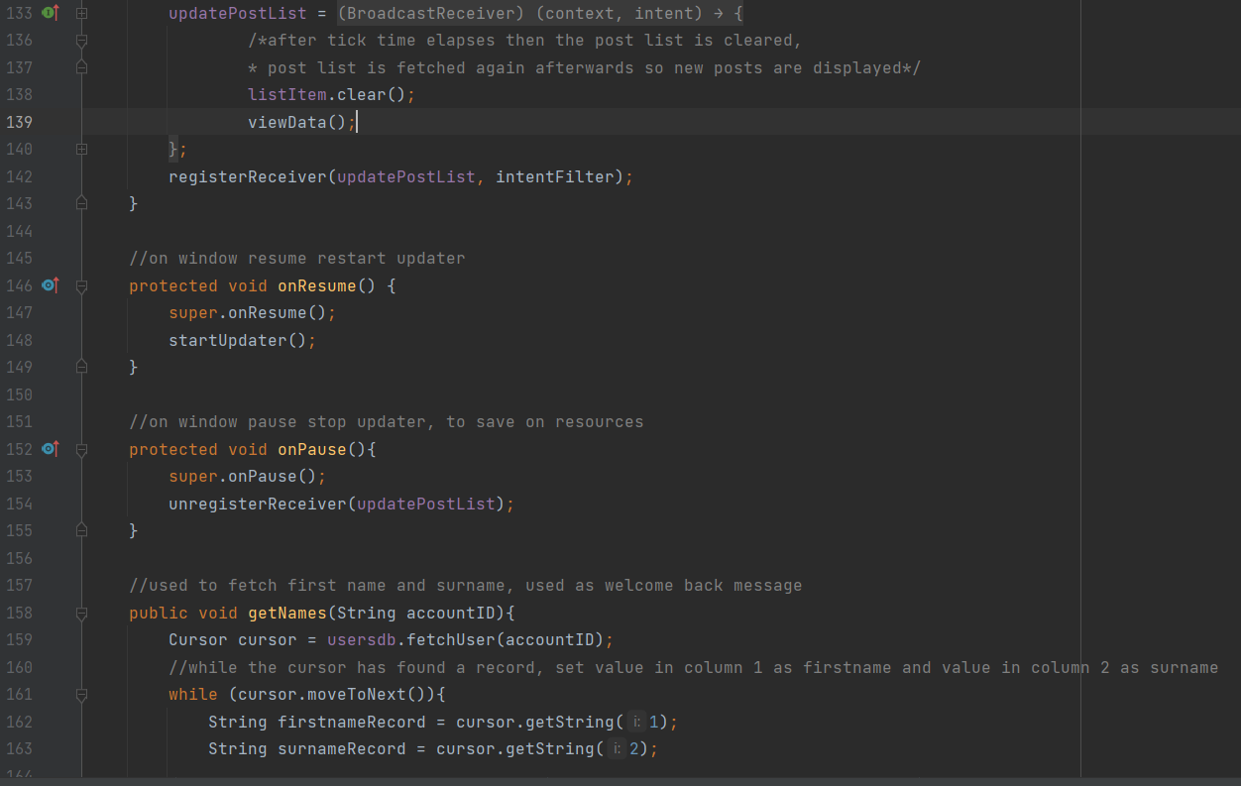

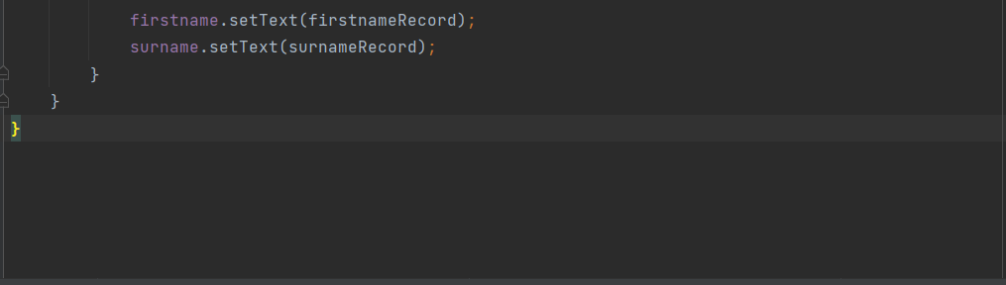

Key Features Activity Screenshots:

As part of this section of the report the author has created a navigation diagram, this is to help the user understand how activities are linked together.

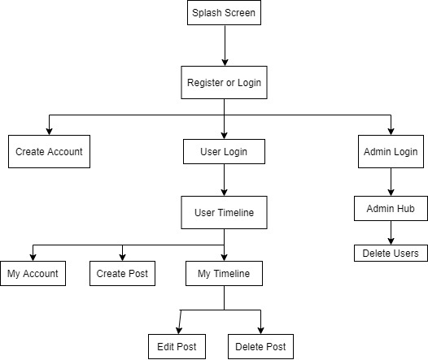

Splash Screen

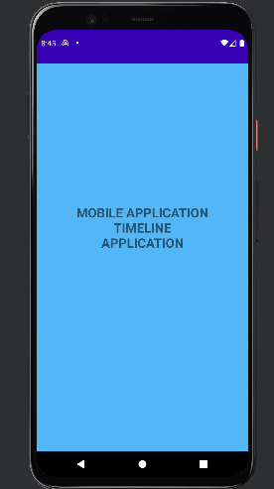

Register or Login

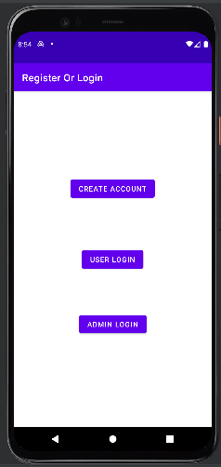

Create Account

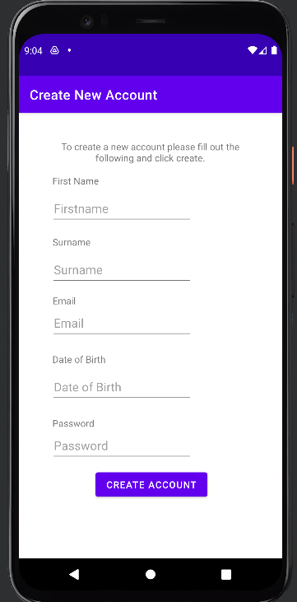

User Login

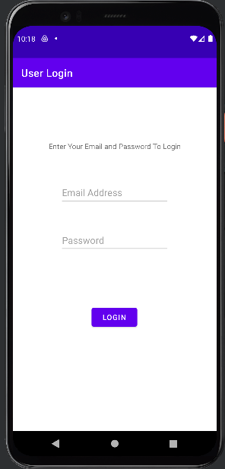

User Timeline

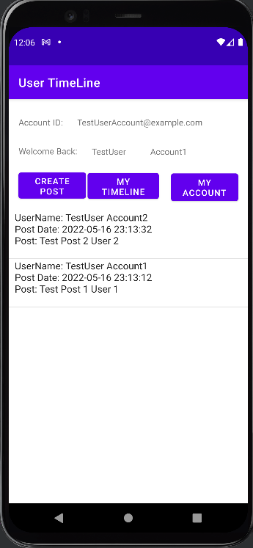

My Account

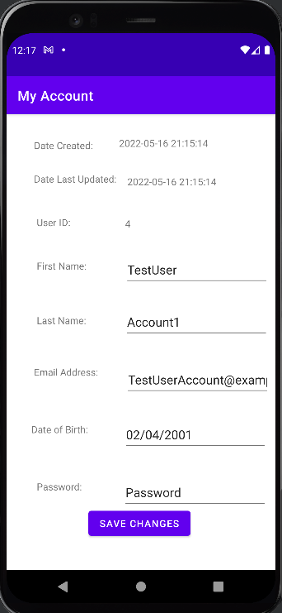

MyTimeline

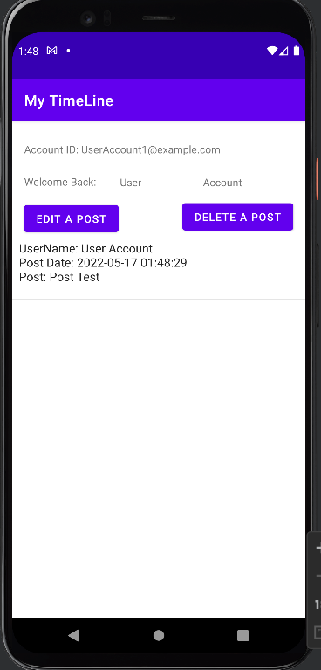

Create Post

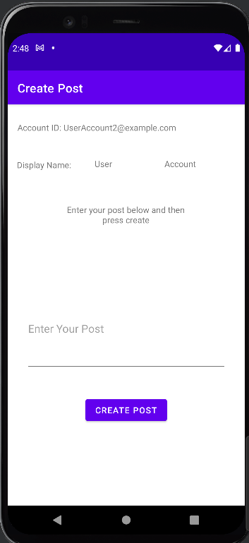

Edit Post

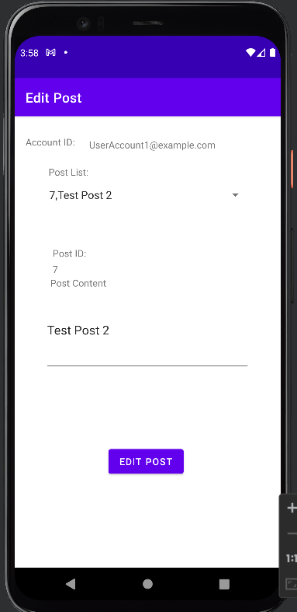

Delete Post

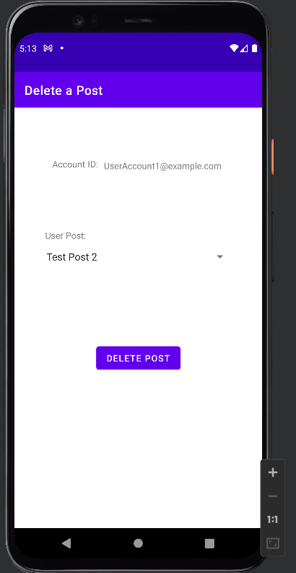

Admin Login

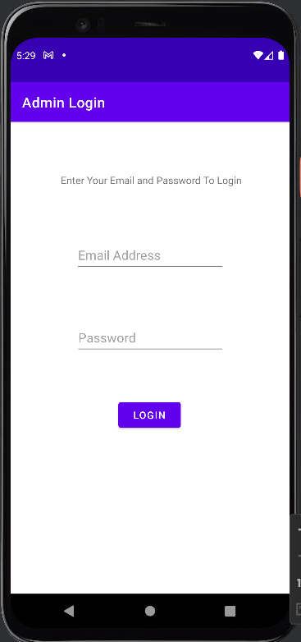

Admin Hub

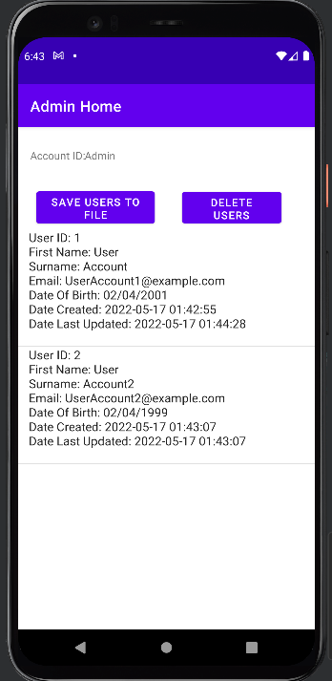

Delete User

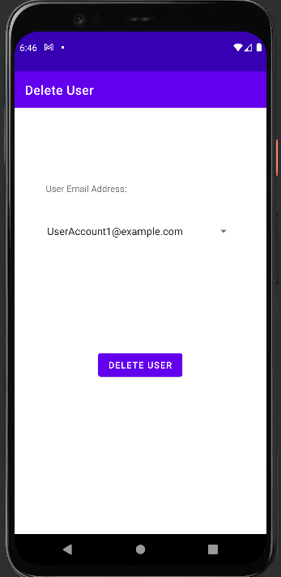

Evidence of Testing:

Black Box Testing:

|  |  |  |  |  |  |
| --- | --- | --- | --- | --- | --- |
| Test ID | | | 1 | | |
| Test Case Description | | | Opening App | | |
| Pre-requisite | | | N/A | | |
| Step Number | Action | Expected Output | Actual Output | Pass / Fail | Test Comments |
| 1 | Launch Application | App Splash Screen appears, no banner present and displays the assignment title | As expected | Pass |  |
| 2 | Open Next Activity | After 3 seconds splash screen disappears and the activity gives the user the option to register an account, user login or admin login is on the next activity. | As expected | Pass |  |
| 3 | Register or Login | Activity Screen is easy and clear to understand, with no overlap or missing text | As expected | Pass |  |

|  |  |  |  |  |  |
| --- | --- | --- | --- | --- | --- |
| Test ID | | | 2 | | |
| Test Case Description | | | Registering an Account | | |
| Pre-requisite | | | N/A | | |
| Step Number | Action | Expected Output | Actual Output | Pass / Fail | Test Comments |
| 1 | Open create account activity | When the create button is clicked the registration activity opens | As expected | Pass |  |
| 2 | Create Account activity | The create account activity is clear to read, no text is missing or overlapping | As expected | Pass | Create Account button was moved up after the first test to make sure it is not hugging the bottom of the phone screen. |
| 3 | Create an Account – Positive Test Case | All fields are filled in the form and the create account button is clicked. Users should get a toast message prompt telling them the account has been created and the row should be in the database. | As Expected | Pass |  |
| 4 | Create multiple Accounts – Positive Test Case | Another form is filled in and submitted. The database should save this as a new different user. | As Expected  (See Database Evidence) | Pass |  |
| 5 | Create an Account – Negative Test Case | A register form is filled but a field is left blank, this should display a toast asking the user to fill in all fields, a database record is not created. | As Expected, the screenshot only shows testing with one field empty but was tested with all missing, and then tested repeatedly with a different field missing each time. | Pass |  |

|  |  |  |  |  |  |
| --- | --- | --- | --- | --- | --- |
| Test ID | | | 3 | | |
| Test Case Description | | | User Login | | |
| Pre-requisite | | | User details from the Users Table | | |
| Step Number | Action | Expected Output | Actual Output | Pass / Fail | Test Comments |
| 1 | Opening the Login Activity | When clicked the log in button opens the user login activity. | As Expected | Pass |  |
| 2 | Viewing the Login Activity | The activity is clear to read, no text is missing or overlapping | As Expected | Pass |  |
| 3 | Logging into an account – Positive Test Case | The user details are correct, when the user clicks login the next window opens with the user hub. | As Expected | Pass |  |
| 4 | Logging into an account – Negative Test Case | When the user tries to log in with an account that does not exist they are presented with a toast message telling them that the account does not exist. |  | Pass |  |
| 5 | Logging into an account – Negative Test Case | When the user tries to log in without all the fields filled they get a toast message telling them that all fields are needed. | As expected | Pass |  |

|  |  |  |  |  |  |
| --- | --- | --- | --- | --- | --- |
| Test ID | | | 4 | | |
| Test Case Description | | | User Home | | |
| Pre-requisite | | | Successful login via the user login | | |
| Step Number | Action | Expected Output | Actual Output | Pass / Fail | Test Comments |
| 1 | Opening activity – Negative Case Test (No Posts). | The activity opens after the user logins, no posts are loaded as there are none to display, and a toast message is displayed to let the user know this. | As Expected | Pass |  |
| 2 | Opening activity – Positive Case | The activity opens after the user logins, and posts by all users are loaded into the platform | As Expected | Pass |  |
| 3 | Viewing the Activity Layout | The activity is clear to read, no text is missing or overlapping | Account ID is hidden by my account button. | Fail | Fixed by putting the, my account button in a different position |

|  |  |  |  |  |  |
| --- | --- | --- | --- | --- | --- |
| Test ID | | | 5 | | |
| Test Case Description | | | Viewing My Account | | |
| Pre-requisite | | | Being logged in with a User Account | | |
| Step Number | Action | Expected Output | Actual Output | Pass / Fail | Test Comments |
| 1 | Opening activity | The activity opens after the My Account button is clicked on the user timeline | As Expected | Pass |  |
| 2 | Fetching the users account | When the activity opens it fetches current users' account details | As Expected | Pass |  |
| 3 | Viewing the My Account activity | The activity is clear to read, no text is missing or overlapping | As Expected | Pass |  |
| 4 | Editing the user's account – Positive Test Case | A user changes a value in the activity and when they press save that value is altered in the table and the date last updated changes. | As Expected | Pass |  |
| 5 | Editing the Users account – Negative Test Case (Submitting a Partly Empty Form) | If a user tries to submit a form that doesn’t have all the fields in it then a toast message is displayed asking the user to input all fields. Record update does not occur. | As Expected | Pass | Appears to look like all fields are present but on the edit button press the activity is reloaded so user details are refilled back into all slots |

|  |  |  |  |  |  |  |  |  |  |
| --- | --- | --- | --- | --- | --- | --- | --- | --- | --- |
| Test ID | | | | | 6 | | | | |
| Test Case Description | | | | | My Timeline | | | | |
| Pre-requisite | | | | | Being logged in with a User Account | | | | |
| Step Number | | Action | | Expected Output | Actual Output | | Pass / Fail | | Test Comments |
| 1 | | Activity opens | | My Timeline activity is opened when the user clicks the My Timeline Button in the user's home activity. | As Expected | | Pass | |  |
| 2 | | Viewing the activity | | The activity is clear to read, no text is missing or overlapping | There is overlap between the buttons and posts | | Fail | | Overlap with buttons and the list view that displays posts. Fixed by changing XML layout |
| 3 | | Opening the activity (No Posts) | | The activity shows the user a toast message saying that no posts are found | As Expected | | Pass | |  |
| 4 | | Opening the activity (Posts) | | The activity loads all the posts created by that user | As Expected | |  | | Example of all records that time in the user timeline to show that only the logged in users are retrieved when My Timeline is opened. |
| Test ID | | | | | 7 | | | | |
| Test Case Description | | | | | Create Post | | | | |
| Pre-requisite | | | | | Logging using a user account | | | | |
| Step Number | Action | | Expected Output | | Actual Output | Pass / Fail | | Test Comments | |
| 1 | Activity Opens | | The create post-activity opens when the create post button is clicked | | As Expected | Pass | |  | |
| 2 | Viewing the activity | | The activity is clear to read, no text is missing or overlapping | | As expected | Pass | |  | |
| 3 | Create Post – Positive Test Case | | The user can enter post content and when they create post button is clicked the post is saved to the database | | As Expected | Pass | |  | |
| 4 | The new post can be viewed on the timeline | | The post that was just created is viewable on the user's Timeline and the general timeline | | As Expected | Pass | | The refresh timer is a little longer than ideal so the user may think the post has not been added to the timeline, reducing the timer and a visual refresh prompt could resolve this issue. | |
| 5 | Create post – Negative test Case | | The user creates a post with a missing value. A toast message is displayed asking the user for all values and the post is not created. | | As Expected | Pass | |  | |

|  |  |  |  |  |  |
| --- | --- | --- | --- | --- | --- |
| Test ID | | | 8 | | |
| Test Case Description | | | Edit Post | | |
| Pre-requisite | | | Logging using a user account | | |
| Step Number | Action | Expected Output | Actual Output | Pass / Fail | Test Comments |
| 1 | Activity opens | The activity opens when the edit post button is clicked, fields are prefilled with information about the user and their posts. | As Expected | Pass |  |
| 2 | Viewing the activity | The activity is clear to read, no text is missing or overlapping | As Expected | Pass |  |
| 3 | Editing a Post | When the user selects a post on the spinner the post is loaded | As Expected | Pass |  |
| 4 | Editing a post – Positive Test Case | When the user presses the update button the change to the post is submitted and the activity is refreshed to show the user that their changes have been made. | As Expected | Pass |  |
| 5 | Editing a post – Negative Test Case | When the user submits a post with no content in a toast message is displayed telling them that all fields are required and that | As expected | Pass |  |

|  |  |  |  |  |  |
| --- | --- | --- | --- | --- | --- |
| Test ID | | | 9 | | |
| Test Case Description | | | Delete Post | | |
| Pre-requisite | | | Logged in a standard user | | |
| Step Number | Action | Expected Output | Actual Output | Pass / Fail | Test Comments |
| 1 | Activity opens | The activity opens when the delete post button is clicked | As expected | Pass |  |
| 2 | Viewing the activity | The activity is clear to read, no text is missing or overlapping | As expected | Pass |  |
| 3 | Selecting Posts | All posts created by the current logged in user can be selected in the spinner. | As expected | Pass |  |
| 4 | Deleting Posts | When the button is clicked the selected post is deleted and the activity is reloaded to ensure up to date information is shown. | As expected | Pass |  |

|  |  |  |  |  |  |
| --- | --- | --- | --- | --- | --- |
| Test ID | | | 10 | | |
| Test Case Description | | | Admin Login | | |
| Pre-requisite | | | Admin Login from the Admin Table | | |
| Step Number | Action | Expected Output | Actual Output | Pass / Fail | Test Comments |
| 1 | Opening the Admin  Login Activity | When clicked the log in button opens the admin login activity. | As Expected | Pass |  |
| 2 | Viewing the Admin Login Activity | The activity is clear to read, no text is missing or overlapping | As Expected | Pass |  |
| 3 | Logging into an account – Positive Test Case | The admin details are correct, when the admin clicks login the next window opens with the user hub. | As Expected | Pass |  |
| 4 | Logging into an account – Negative Test Case | When the user tries to log in with an account that does not exist they are presented with a toast message telling them that the account does not exist. | As Expected | Pass |  |
| 5 | Logging into an account – Negative Test Case | When the admin tries to log in without all the fields filled they get a toast message telling them that all fields are needed. | As expected | Pass |  |

|  |  |  |  |  |  |
| --- | --- | --- | --- | --- | --- |
| Test ID | | | 11 | | |
| Test Case Description | | | Admin Hub | | |
| Pre-requisite | | | Admin Account Login | | |
| Step Number | Action | Expected Output | Actual Output | Pass / Fail | Test Comments |
| 1 | Opening the Admin  Hub Activity | Admin Home is opened immediately after a successful admin login from the user.  All the User Accounts are displayed on the screen for the admin to see.  A Toast message is displayed telling the user where the user file is saved to. | As Expected | Pass |  |
| 2 | Viewing the Admin Hub Activity | The activity is clear to read, no text is missing or overlapping | As Expected | Pass |  |
| 3 | Save Users to File | When clicked a Toast message is displayed and all the accounts are written to a file. | As Expected | Pass |  |

|  |  |  |  |  |  |
| --- | --- | --- | --- | --- | --- |
| Test ID | | | 12 | | |
| Test Case Description | | | Delete User | | |
| Pre-requisite | | | Login for Admin Account | | |
| Step Number | Action | Expected Output | Actual Output | Pass / Fail | Test Comments |
| 1 | Opening the Delete Users  Activity | Delete users activity opens after the delete users button is clicked, Spinner is prefilled with the user ID (Email address) of all users in the database. | As Expected | Pass |  |
| 2 | Viewing the Delete Users Activity | The activity is clear to read, no text is missing or overlapping |  | Pass |  |
| 3 | Delete Button Clicked | When clicked the delete button removes the user and all their posts. | As Expected |  | The original record that was created is shown below as well as evidence that the record is no longer present. |

Known Bugs and Weaknesses

Bugs:

|  |  |
| --- | --- |
| Activity or Class Related To | Bug |
| Admin Hub | Handler code not implemented. List view does not update so the admin needs to leave the activity and reload it manually to get an up to date list. |

Weaknesses:

|  |  |
| --- | --- |
| Activity or Class Related To | Weakness |
| Registering an Account | No checking for duplicate email addresses in the system, as emails are used as the main key this can result in accidental duplicate insertions or deletes. |
| Creating a post | Can delete posts with the same content by the same user as there are no additional checks for duplicate posts. |
| Registering an Account | No checking for valid emails, user can enter anything into the box. |
| Registering an Account | No valid checking or formatting for date of birth so the user can enter anything. |
| Registering an Account | No strength checking for passwords so users can use very weak passwords and risk being hacked. |
| Admin Login | No ability to create new admin accounts within the application must be created manually. |
| UserHome, MyTimeLine, adminHub | The timer counts down for the timeline refresh is not obvious and the tick length is too long so it’s hard for users to know that it is refreshing. Could od with a countdown timer and reducing the length of time between refreshes. |
| No logs (All Activity) | There is no use of logs throughout the code, this can make the code harder to maintain and repair if it breaks. |
| Registering an Account | No password validity checker, therefore, if a user makes a spelling mistake with their account creation they would not know and would not be able to log in |
| Registering an Account | No form of hashing or security for passwords, this means the security of the app is very weak. |

References

Aman Singh (2016) Reload activity in Android. *Stack Overflow* [online]. Available from: <https://stackoverflow.com/questions/3053761/reload-activity-in-android> [Accessed date: 13/05/2022].

Coding in Flow (2017) How to Update the UI with Every New Minute – Android Studio Tutorial. *YouTube* [online]. Available from: <https://www.youtube.com/watch?v=hXWVaAyXkoQ&ab_channel=CodinginFlow> [Accessed date: 12/05/2022].

Coding Pursuits (2021) How to Pass Data From One Activity to Another Activity in Android Studio.*YouTube* [online]. Available from: <https://www.youtube.com/watch?v=4NZ0P07NfSM&ab_channel=CodingPursuits> [Accessed date: 12/05/2022].

KOD Dev (2018) SQLite Database to ListView – Part 3: View Data – Android Studio Tutorial. *YouTube* [online]. Available from: <https://www.youtube.com/watch?v=N-gHIJShz1I&ab_channel=KODDev> [Accessed date: 12/05/2022].

Luke Vo (2011) Auto refresh the activity. *Stack Overflow* [online]. Available from: <https://stackoverflow.com/questions/6134832/auto-refresh-the-activity> [Accessed date: 14/05/2022].

Nick (2017) How to add date of creation of record in sqllite table in android and later display all records ordering by date. *Stack Overflow* [online]. Available from: <https://stackoverflow.com/questions/45126614/how-to-add-date-of-creation-of-record-in-sqlite-table-in-android-and-later-displ> [Accessed date: 13/05/2022].

Thomas Hamilton (2022) What is BLACK Box Testing? Techniques, Example & Types. *Guru99* [online]. Available from: <https://www.guru99.com/black-box-testing.html> [Accessed date: 16/05/2022].